Slindon Church of England Primary School

MFL Policy
Modern Foreign Languages

Approved by: | Headteacher (Laura Webb)
Date: | October 2025
Last reviewed on: | October 2025
Next review due by: | October 2026

Contents
1. Introduction 3
2. Aims………………………………………………………………………………………………………………………………….6

- Introduction
Vision

At Slindon CofE Primary school we serve our local community and enable our school family to flourish. We recognise that everyone is Unique and want to ensure they are able to Learn and Develop in a high quality learning environment. We enrich the spirit in an Enabling Environment, in which Positive relationships foster creativity and curiosity. In hope we encourage our community to shine brightly and be courageous advocates of our world, shaping their futures for the better.
The Fruit of the Spirit is love, joy, peace, patience, kindness, goodness, faithfulness, gentleness and self-control; against such things there is no law.
Galatians 5; 22-23
Let Your Light Shine ~ Matthew 5:16

Slindon Church of England Primary School is led by four overarching principles. These principles run through the ethos of our school and feed into our policy and pedagogy.
Within our Modern Foreign Languages (MFL) education, we recognise that all children are unique. We know our children well and appreciate their different and varying experiences. Our MFL curriculum is designed with sensitivity to the uniqueness of each child.
We respect that everybody learns and develops in different ways. Our MFL curriculum respects the developmental needs of children, through carefully planned, age-appropriate content. Our MFL curriculum is delivered using a variety of strategies to ensure that all children are able to succeed.
The calm climate for learning within our classrooms and outdoor learning areas provides an enabling environment for children to learn and feel safe to explore themes within our MFL curriculum.



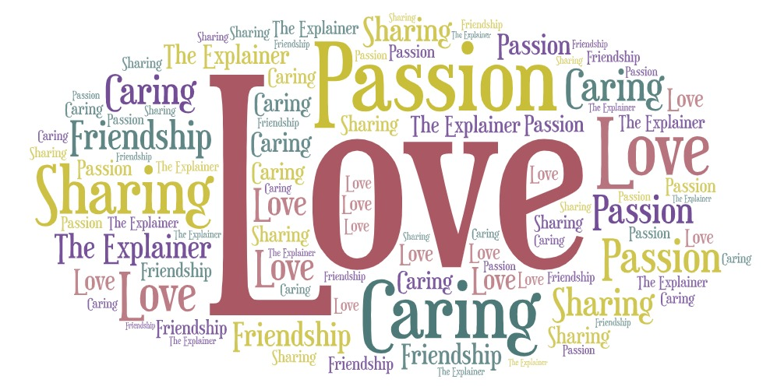

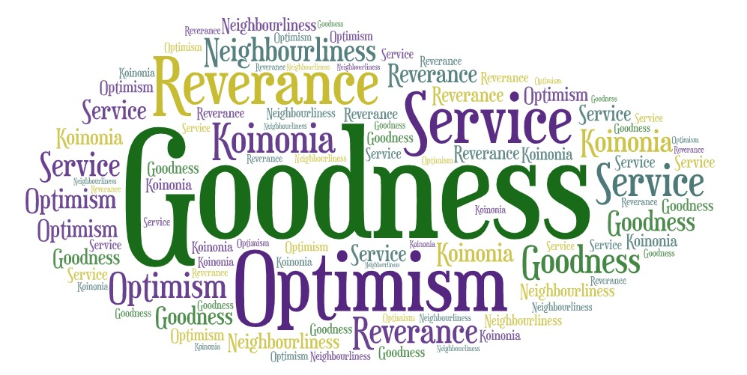
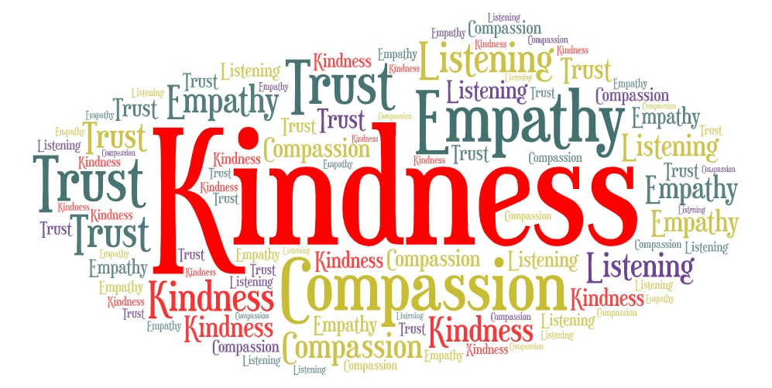



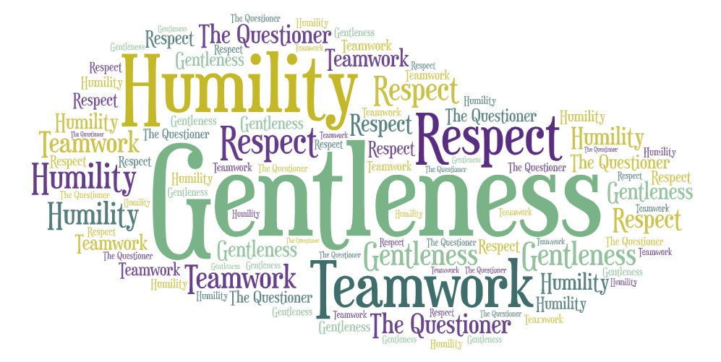
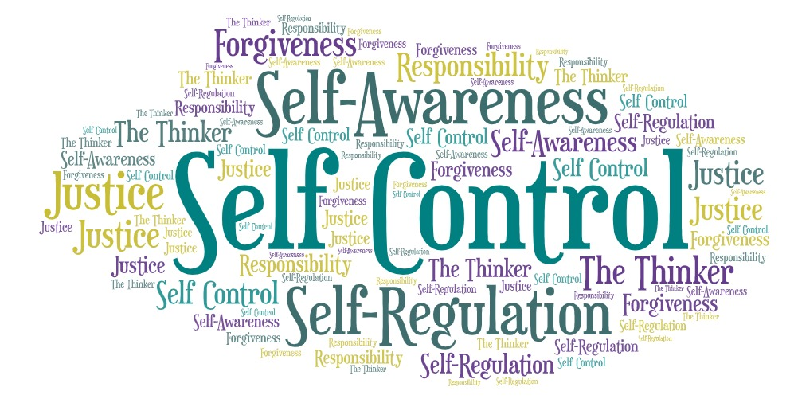

As a Rights Respecting School, our MFL Policy is underpinned by the following articles of the UN Convention on the Rights of a Child.

- Articles 3/ 5: The adults in our school community, including our parents/ carers and families will act as role models. The best interests of our children are our top priority in all decisions and actions.
- Article 8: Every child has the right to an identity.
- Articles 2/ 12/ 30: We respect the right to be listened to and listen to others, to give an opinion and have the right to protection against discrimination.
- Article 13: We respect the right to find things out and share what we think with others, through art, talking or writing, unless it breaks the rights of others.
- Article 14: We respect the right to think and believe what we chose and to practice religion, as long as we are not stopping people from enjoying their rights.
- Article 15/ 31: We respect the right to meet with other children and to join groups and organisations, as long as we are not stopping people from enjoying their rights.
- Article 17: We respect the right to collect information from radio, newspapers, television and the internet, but to also be protected from information that could be harmful.
- Articles 19/ 24: We respect the right to feel safe at school and help others feel safe, to not be hurt or badly treated.
- Article 28: We respect the right to learn and let others enjoy their learning.
- Article 29: We respect the right to develop our potential.

- Aims
At Slindon Church of England Primary School we have chosen to learn French as our Modern Foreign Language. Our aims for learning French fulfill those outlined in the national curriculum and aim to ensure that all pupils:
- understand and respond to spoken and written language from a variety of authentic sources
- speak with increasing confidence, fluency and spontaneity, finding ways of communicating what they want to say, including through discussion and asking questions, and continually improving the accuracy of their pronunciation and intonation
- can write at varying length, for different purposes and audiences, using the variety of grammatical structures that they have learnt
- discover and develop an appreciation of a range of writing in the language studied.

3. Intent
Our vision for Slindon Church of England Primary School is to inspire and nurture children in a secure, caring and happy Christian community, where diversity and individuality are celebrated. We believe that all individuals are of equal worth and we seek to foster mutual respect and responsibility. We encourage children to develop confidence and resilience in an environment where rights are respected, efforts are valued and all children flourish. The teaching and learning of MFL in our school supports and upholds this vision.

The French curriculum at Slindon CE Primary School offers a carefully planned sequence of lessons, ensuring progressive coverage of the skills required by the national curriculum. Woven through the different themes, we introduce the culture of French-speaking countries and communities. This aims to foster children’s curiosity and help deepen their understanding of the world. A linear curriculum has been chosen to allow opportunity for children to gradually build on their skills. French enables children to express their ideas and thoughts in French and provides opportunities to interact and communicate with others both in speech and in writing. At the heart of French is the desire to expose children to authentic French, so the scheme offers regular opportunities to listen to native speakers.
In Lower KS2, children acquire basic skills and understanding of French with a strong emphasis placed on developing their Speaking and Listening skills. These will be embedded and further developed in Upper KS2, alongside Reading and Writing, gradually progressing onto more complex language concepts and greater learner autonomy. In all years, vocabulary, grammar and phonics will be taught in French lessons.
Through our French curriculum, we intend to inspire pupils to develop a love of languages and to expand their horizons to other countries, cultures and people. We aim to help children grow into curious, confident and reflective language learners and to provide them with a foundation that will equip them for further language studies.

Implementation
Weekly, 45 minute French lessons are taught in Lower and Upper Key stage 2. Our spiralling curriculum is delivered through a 2-year rolling programme of study in Acorn (LKS2) and Chestnut (UKS2) classes.
At Slindon, French lessons are sequenced, so that prior learning is considered and opportunities for revision of language and grammar are built in.
We plan and adapt lessons and use resources tailored to the children. The aim is to build on prior knowledge alongside the introduction of new skills. A series of lessons provide structure and context as well as offering an insight into the culture of French-speaking countries and communities. The introduction and revision of key vocabulary and grammatical structures is built into each lesson. This vocabulary is then included in display materials and additional resources so that children have opportunities to repeat and revise their learning.

- Impact
At Slindon we use a range of resources, including display materials, in order to increase the profile of languages across school. The learning environment is consistent with key French vocabulary displayed, spoken and used by all learners. Whole-school and parental engagement is encouraged through the use of half-termly knowledge organisers published on the school website. During lessons we also suggest opportunities for wider learning. We want to ensure that French is loved by teachers and pupils across school, therefore encouraging them to embark on further language studies. Impact can also be measured through retrieval practice and key questioning built into lessons, child-led assessment, and summative assessments aimed at targeting next steps in learning.

MFL is assessed termly in line with our Foundation Subjects Assessment procedure. Knowledge Organisers are provided for each unit of work and include the key French vocabulary. Each week the children are assessed on the key learning objectives; we use regular retrieval practice at the beginning of each lesson, written work, discussion and pupil voice to make an accurate teacher assessment of each pupil’s progress.

Children’s progress in MFL will be reported to parents in the end of year report.

Inclusion

We recognise that in all classes, children have a wide range of ability, and so we seek to provide suitable learning opportunities for all children by matching the challenge of the task to the ability of the child. We achieve this in a variety of ways:
• setting tasks which are open-ended and can have a variety of responses;
• setting tasks of increasing difficulty;
• providing resources of different complexity, depending on the ability of the child.

6. Roles and responsibilities
6.1 The governing board
The governing body are responsible for monitoring MFL, approving the MFL policy and hold the Headteacher to account for its implementation.
6.2 The Headteacher
The Headteacher is responsible for ensuring that MFL is taught consistently across the school.
6.3 Staff
Staff are responsible for:
- Delivering MFL in an inspiring way
- Modelling positive attitudes to MFL
- Monitoring progress
- Responding to the needs of individual pupils and cohorts

7. Monitoring arrangements
The delivery of MFL is monitored by the MFL lead teacher, Nathalie Soal, through:
Planning scrutiny, work scrutiny, analysis of foundation assessment data, consultation with pupils and staff.
This policy will be reviewed by Nathalie Soal MFL lead teacher each year. At every review, the policy will be approved by the Headteacher.

8. Links with other policies
This policy links to the following policies and procedures:
Special Educational Needs and Disabilities Policy
Equal Opportunities Policy
Behaviour Policy

