|  |  |
| --- | --- |
| **Key Vocabulary** | |
| **Dinosaurs** | A group of extinct reptiles that lived millions of years ago. |
| **Timelines** | A timeline is a line that shows events in the order they happened. |
| **Characteristics** | Special qualities or features of something. |
| **Fossils** | The remains or traces of plants and animals that lived long ago. |
| **Extinction** | When all members of a species have died. |
| **Mary Anning** | A famous fossil hunter who made important discoveries. |
| **Museum** | A place where artefacts and specimens are displayed for public viewing. |
| **Prehistoric** | The period before written history/ records. |
| **Past** | The past is the time that has already happened. |
| **Changes** | The process of when something becomes different from what is was previously. |
| **Palaeontologists** | Scientists who study fossils to learn about the past. |
| **Carnivore** | Someone/something that only eat meat. |
| **Herbivore** | Someone/something that only eat plants. |
| **Predator** | An animal that hunts and eats other animals. |
| **Prey** | An animal that is hunted and eaten by a predator. |
| **Excavate** | To dig something up from the ground, often fossils. |
| **Pangea** | Pangea was a huge landmass where all the continents were joined together a long time ago. |
| **Jurassic** | One of the periods when the dinosaurs lived, 200 – 145 million years ago. |
| **Triassic** | One of the periods when the dinosaurs lived, 252 – 200 million years ago. |
| **Cretaceous** | One of the periods when the dinosaurs lived, 145 – 66 million years ago. |

 

**Knowledge Outcomes:**

* To understand what dinosaurs are and when they existed.
* I can identify characteristics and relatives of dinosaurs.
* To explore prehistoric geography.
* To understand fossils and their importance.
* To learn about Mary Anning and her contributions.
* To investigate the extinction of the dinosaurs.

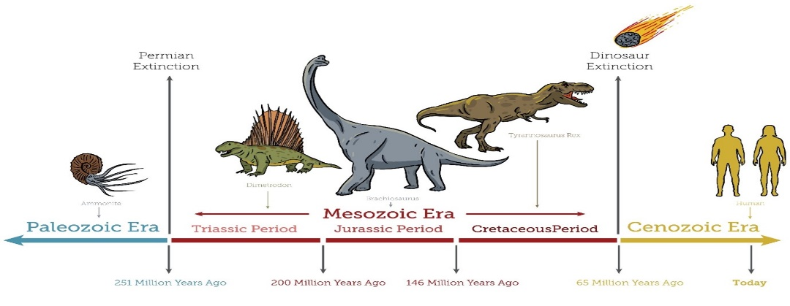

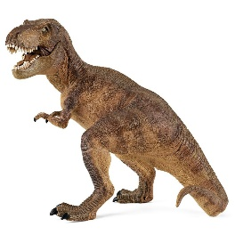

**Interesting facts!**

Did you know the T-Rex had teeth up to 30cm long!

Some fossils show that dinosaurs had feathers, like modern day birds.



**EYFS LINKS**

**Communication and Language: Listening, Attention and Understanding.**

|  |
| --- |
| Learn new vocabulary  Use new vocabulary through the day  Ask questions to find out more and to check they understand what has been said to them.  Articulate their ideas and thoughts in well-formed sentences.  Connect one idea or action to another using a range of connectives.  Describe events in some detail  Use talk to help work out problems and organise thinking and activities explain why they might happen. |

**Understanding the World: Past and Present**

Talk about the lives of the people around them and their roles in society.

Know some similarities and differences between things in the past and now, drawing on their experiences and what has been read in class.

Understand the past through settings, characters and events encountered in books read in class and storytelling.

