Key Vocabulary
Knowledge Outcomes:

- I can identify and name a variety of common wild and garden plants, including examples of both deciduous and evergreen trees.
- I can describe the basic structure of common flowering plants, including flowers, leaves, stems, and roots.
- I can recognise and name the parts of a tree: roots, trunk, branches, and leaves.
- I can observe and describe how seeds and bulbs grow into mature plants, using appropriate vocabulary.
- I can understand the basic needs of plants for growth: water, light, and suitable temperature.
- I can ask simple questions about plants and use observations to suggest answers.
- I can record and communicate findings about plants in simple scientific language.

Plant | A living thing that grows in the Earth and has a stem, leaves, and roots.
Tree | A tall plant that has parts including a trunk, branches, and leaves.
Roots | The part of the plant that grows underground.
Trunk | The large main stem from which the branches grow.
Branches | Parts that grow from the tree trunk and have leaves, flowers or fruit growing from them.
Leaves/leaf | The parts of the tree that are usually green and can be found in different shapes depending on the tree.
Needles | The sharp leaves of some evergreen trees like pines.
Evergreen | A tree or bush that has green leaves all year round.
Deciduous | A tree that loses its leaves in the autumn each year.
Fruit | A food that grows on a tree or bush and contains seeds or a stone.
Vegetable | A food that grows in the ground such as a potato and does not have seeds.
Vegetation | Plants, trees, and flowers.
Garden | A piece of land next to a house, with flowers, vegetables, and grass.
Herb | The leaves of a plant that are used in cooking to add flavour to food.
Flower | The part of the plant which is brightly coloured and grows at the end of the stem.
Growth | The process of a plant increasing in size and developing.
Soil | The top layer of the earth where plants grow, containing nutrients.
Buttercup | A yellow wildflower often found in meadows.
Nettle | A common wild plant with stinging leaves.
Seed | The small part from which a new plant grows.
Stem | The thin, upright part of a plant on which flowers and leaves grow.
Sunflower | A tall plant with a large yellow flower that turns to follow the sun.
Daisy | A common wildflower with white petals and a yellow centre.
Wildflower | A flower that grows naturally in the wild without being planted by people.
Trunk | The thick main stem of a tree that supports branches and leaves.
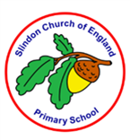

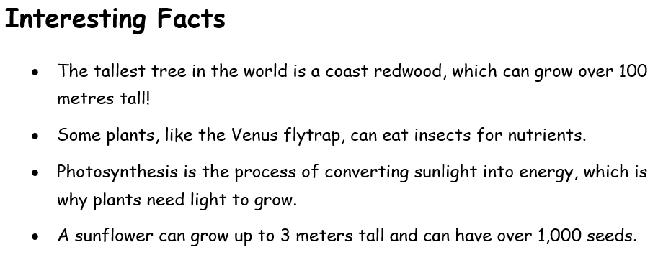
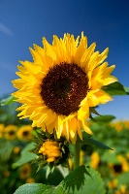

EYFS LINKS
Communication and Language: Listening, Attention and Understanding
Learn new vocabulary.
Use new vocabulary through the day.
Ask questions to find out more and to check they understand what has been said to them.
Articulate their ideas and thoughts in well-formed sentences.
Connect one idea or action to another using a range of connectives.
Describe events in some detail.
Use talk to help work out problems and organise thinking and activities explain why they might happen.

Understanding the World: The Natural World
Explore the natural world around them, making observations.
Know some similarities and differences between the natural world around them and contrasting environments, drawing on their experiences and what has been read in class.
Understand some important processes and changes in the natural world around them, including the seasons.
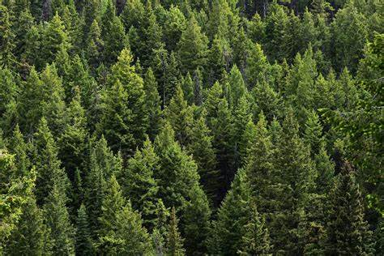


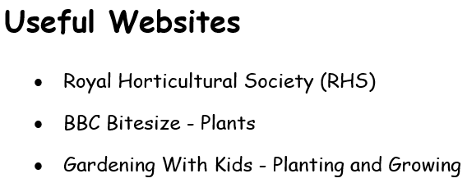
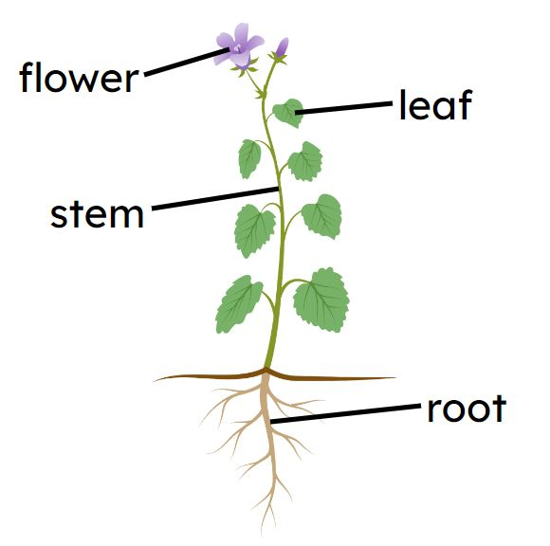
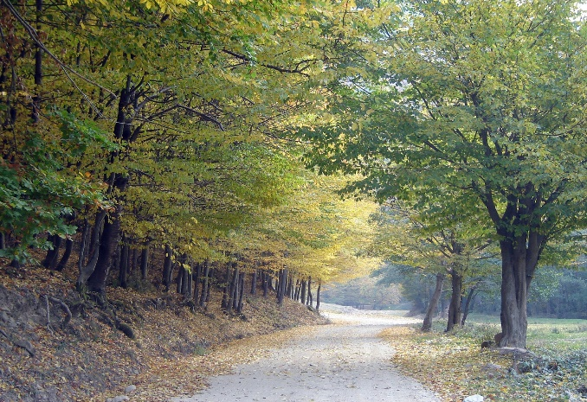
Evergreen
Deciduous

