EYFS Why do Christians perform nativity plays at Christmas?
What should we know?

Christians believe:
- Jesus is a special person.
- Jesus is God’s son.
- Stories in the Bible teach us about Jesus.

Christians:
- Celebrate Christmas because it is the birthday of Jesus.
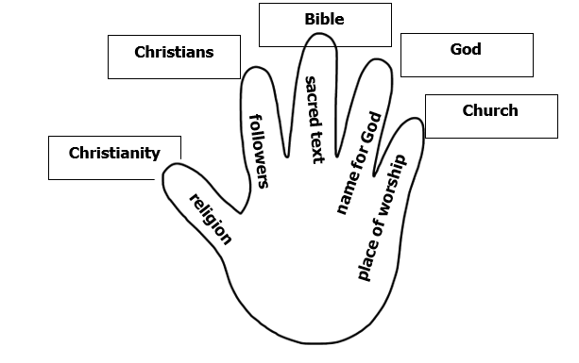
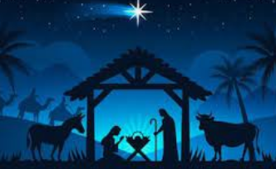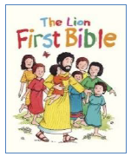
What should we be able to do?
Recognise Jesus in a nativity scene.

Listen to the story of Jesus’ birth from the Bible.

Retell part of the nativity story.

Recognise some of the things Christians do at Christmas.

Vocabulary
God | Christian | service
nativity | followers | miracles
Bible | special | sing
church | Jesus | pray

