UKS2 Should believing in the resurrection change how Christians view life and death?
What should we know?
Resurrection is a word Christians use at Easter. It describes their belief that Jesus was raised from the dead. Stories of the resurrected Jesus are found in the Bible.
Christians try to be a ‘witnesses to the resurrection.’
Christians believe:
- That Jesus was resurrected from the dead.
- Hallelujah is a good word to use at Easter, a time of celebration.
- That death is not the end.
- The resurrection makes a difference in how to live well the right way today and how to help others to also live well.
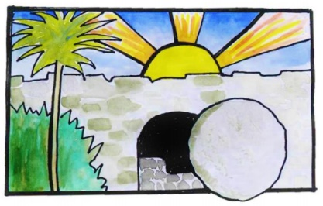

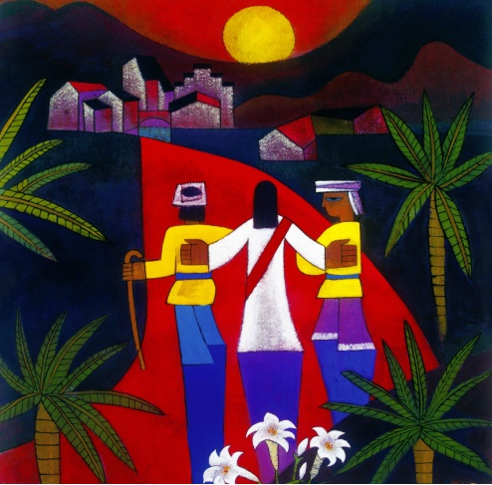
The Road to Emmaus
Prior learning:
That God came into the world in human flesh in the person of Jesus Christ. This is good news.
A cross reminds Christians of his sacrifice, but is also a sign of commitment and God’s love.
In the Gospel, Jesus told parables to teach about God’s Kingdom and the right way to live. Christians serve others as a response to being saved.
God offers forgiveness.
The Eucharist reminds Christians to give thanks daily.
The Holy Spirit reminds Christians God is always with them. He gives them strength.

What should we be able to do?
Retell stories from the Bible of Jesus resurrection.
Use the right religious words to describe practices and experiences involved in Easter celebration.
Explain some Christian teaching about resurrection.
Understand why resurrection makes a difference to a Christian’s life by linking their ideas to different Bible passages.

T
Thgehe

What words should we understand and be able to use?
Resurrection | Resurrection means the raising to life of those who have died. It is a key belief of the Christian faith. | Hallelujah | Hallelujah (Alleluia) is Hebrew for ‘Praise the LORD’ or ‘The Lord’s name be praised. It is used in its original language in Christian worship.
Creed | A list of beliefs, recited by a church congregation as an affirmation of what they believe.

