
Key Vocabulary
Amphibian | A cold-blooded invertebrate animal that comprises frogs, toads, newts, salamanders and caecilians
Asexual reproduction | 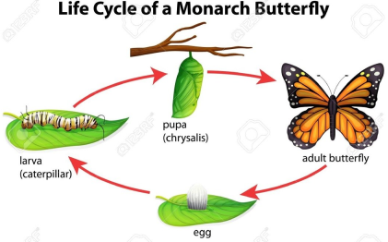  Offspring get genes from one parent so are clones of their parent
Bacteria | Single-celled organisms, most of which can only be seen with a microscope
Bird | A warm-blooded egg-laying vertebrate animal distinguished by the possession of feathers, wings, a beak and typically able to fly
Characteristics | Special qualities or appearances that make an individual or group of things different to others
Classification key | Dividing something into smaller and smaller groups
Fungi | Taxonomic kingdom comprising all the fungus groups and sometimes also the slime moulds
Genus | The group that an organism belongs to
Habitat | The natural home or environment of an animal, plant or other organism
Insect | A small animal that has six legs and generally one or two pairs of wings
Invertebrate | 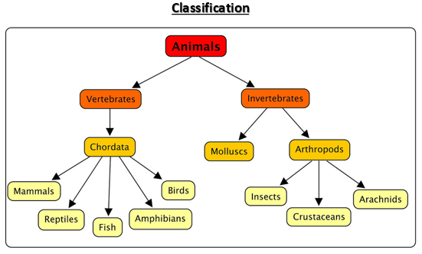  All species of animals without a backbone or internal skeleton
Life cycle | The series of changes in the life of an organism including reproduction
Mammal | A warm-blooded vertebrate animal, distinguishable by the possession of hair or fur, females secreting milk for young and typically giving birth to live young
Metamorphosis | The process of transformation from an immature form to an adult form in two or more distinct stages
Microorganism | A microscopic organism, especially a bacteria, virus or fungus
Organisms | Living things
Sexual reproduction | Offspring get genes from both parents, inheriting a mix of features from both
Species | A class of plants or animals whose members have the same main characteristics and are able to breed with each other
Taxonomy | A branch of science concerned with the classification of organisms
Vertebrate | All species of animals with a spinal cord (backbone)
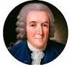
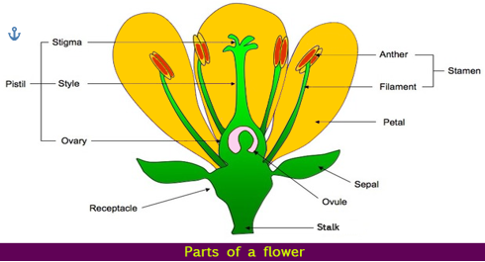

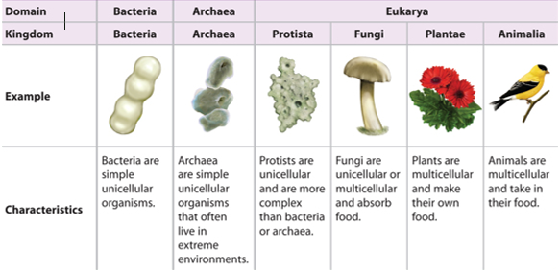

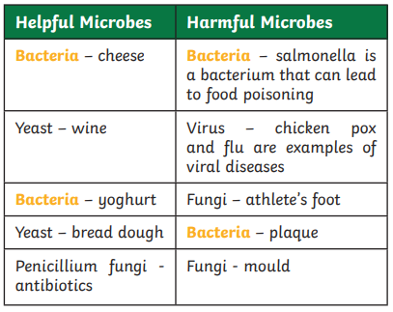
Key Knowledge
- To explain the function of parts of a flower
- To describe features of non-flowering plants and explain the non-flowering plant life cycle
- To describe and compare the life cycle of mammals, birds, amphibians and insects
- To label the structure of an egg
- To use classification keys to group living things according to common observable characteristics
- To explain how living things are classified
- To research Carl Linnaeus
- To investigate helpful and harmful microorganisms
- To classify organisms found in the local habitat

In 1735, Swedish Scientist Carl Linnaeus first published a system for classifying all living things. An adapted version of this system is still used today: The Linnaeus System. Living things can be classified by these eight levels:
Domain, phylum, kingdom, class, order, family, genus, species. The number of living things in each level gets smaller until the one animal is left in its species level.

