|  |  |
| --- | --- |
| **Key Vocabulary** | |
| **compare** | To look at things that are the same and things that are different. |
| **offspring** | An animal’s or child’s young. |
| **Animal** | Living organisms that can move, eat, breathe and reproduce. |
| **human** | Humans are **mammals.** |
| **mammals** | **Mammals** give birth to babies and they feed their young with milk. |
| **carnivore** | An animal that eats meat. |
| **herbivore** | An animal that eats plants. |
| **omnivore** | An animal, which includes humans, eat both meat and plants. |
| **reptile** | Reptiles are cold-blooded animals, with scaly bodies. |
| **amphibian** | Cold-blooded animals that live in water, but breathe air. |
| **exercise** | Physical activity to lead active-healthy lives. |
| **hygiene** | Maintaining good health. |
| **nutrition** | Something we need for health and growth. |
| **Birds** | Animals with feathers, wings and beaks. |
| **Fish** | Animals that live in water and have scales and fins. |

 

**Assessment**

Working Scientifically

* I can explain that different animals have different types of offspring.
* I can find out about, and describe, what animals, including humans, need to survive.
* To find out how animals change as they grow into adults.
* To compare the stages of the human life cycle.
* To test the effects of exercise on the human body.
* To investigate the importance of healthy eating and hygiene.

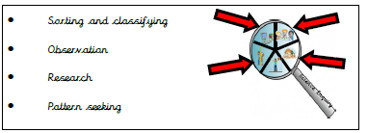

**Science Skills**

* Sorting and Classifying
* Observation
* Research
* Pattern Seeking

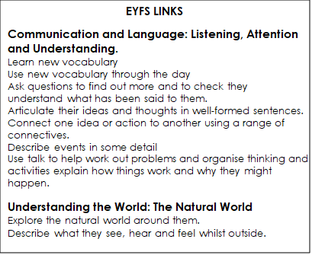

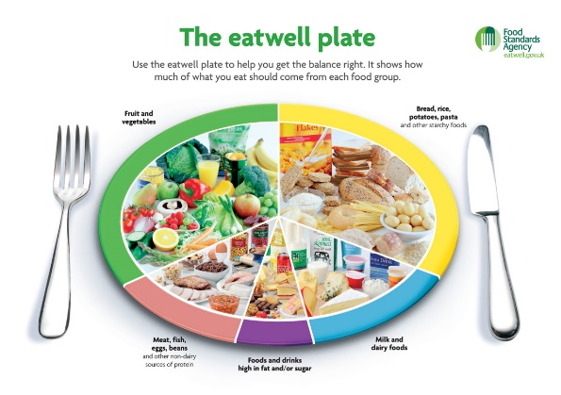

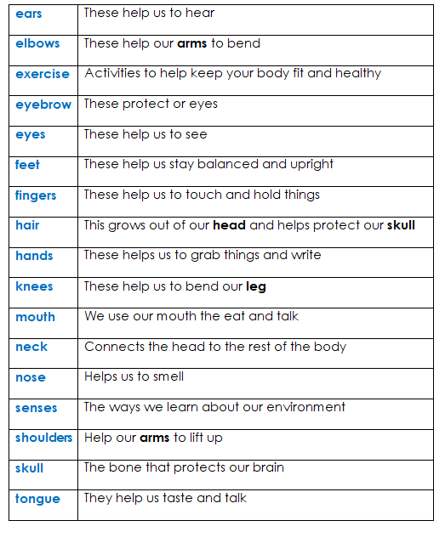

**Human Life Cycle** 