|  |  |
| --- | --- |
| **Key Vocabulary** | |
| **Victorians** | People who lived during the time of Queen Victoria, when many changes occurred in society. |
| **Tudors** | The royal family that ruled England from 1485 to 1603, including Queen Elizabeth I. |
| **Modern Britain** | The current period in British history, including recent events and developments. |
| **Jubilee** | A special celebration marking significant anniversaries of a monarch's reign. |
| **Similarities** | A likeness to something / somebody else. |
| **Differences** | The means by which something / somebody is not alike. |
| **Royal** | A member of a ruling family of a nation. |
| **Monarch** | A king, queen or emperor who rules a country. |
| **Reign** | The time that a monarch rules a country. |
| **Heir / Heiress** | The person who is going to become king or queen next. |
| **Coronation** | When a king or queen begins their reign. |
| **Queen Elizabeth I** | Reigned from 17Th November 1558 until her death in 1603. She reigned for 44 years. |
| **Queen Elizabeth II** | Reigned from 6th February 1952 until her death on 8th September 2022. She reigned for 70 years. |
| **King Charles III** | King Charles III was crowned in May 2023 following the death of his mother Queen Elizabeth II. |
| **Queen Victoria** | Reigned from 1837 until her death in 1901. She reigned for 64 years. |
| **Prince William** | The heir to the British Royal Family. |



**Knowledge Outcomes:**

* I can understand the impact of each monarch on British history.
* I can explore how each monarch lived in different times and contexts.
* I can identify their eras on a timeline.
* I can compare the length of each monarch's reign.
* I can connect personal experiences with the reign of Elizabeth II.

**EYFS LINKS**

**Communication and Language**

**Listening, Attention and Understanding**

Listen attentively and respond to what they hear with relevant questions, comments and actions when being read to and during whole class discussions and small group interactions.

Make comments about what they have heard and ask questions to clarify their understanding.

Hold conversations when engaged in back-and-forth exchanges with their teacher and peers

**Speaking**

Participate in small group, class and one-to-one discussions, offering their own ideas, using recently introduced vocabulary.

Offer explanations for why things might happen, making use of recently introduced vocabulary from stories and non-fiction.

Express their ideas and feelings about their experiences using full sentences, including use of past, present and future tenses and making use of conjunctions, with modelling and support from their teacher

**Understanding the World**

**Past and Present**

Talk about the lives of the people around them and their roles in society.

Know some similarities and differences between things in the past and now, drawing on their own experiences and what has been read in class.

Understand the past through settings, characters and events encountered in books read in class and storytelling.

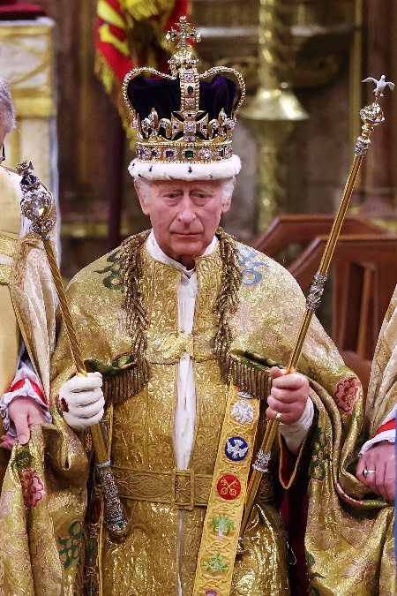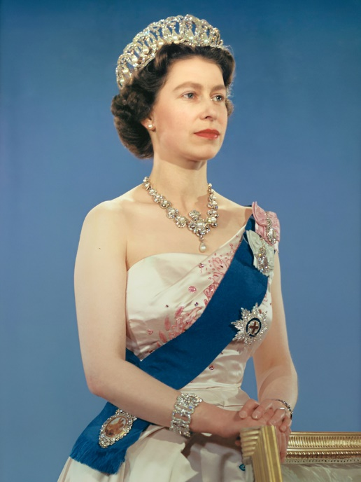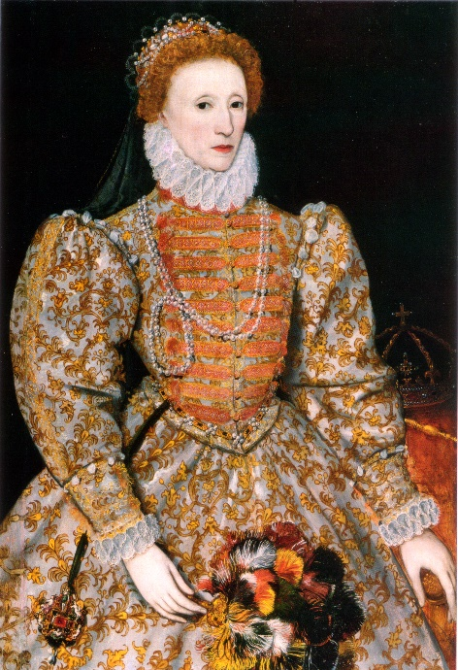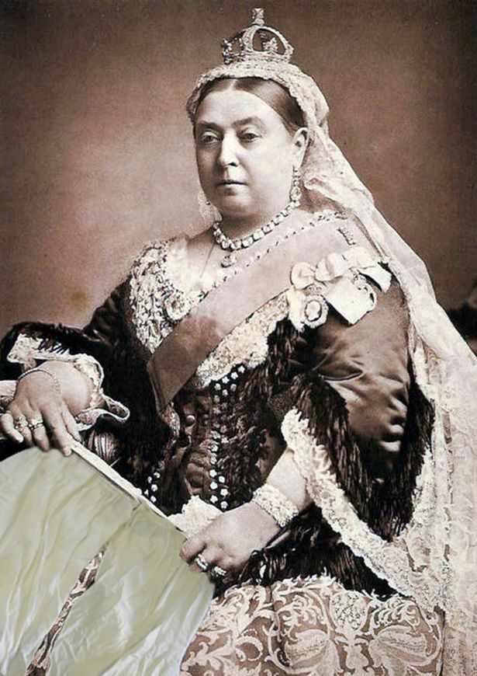

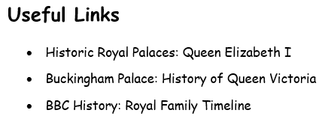

King Charles III

Queen Elizabeth II

Queen Elizabeth I

Queen Victoria