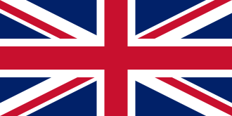

Comparing the UK to North America
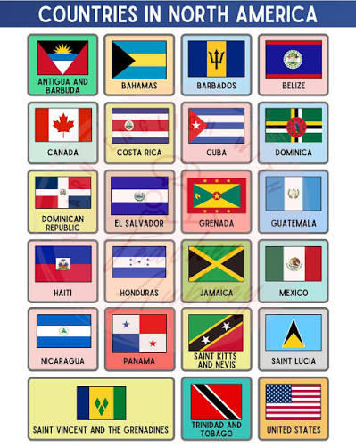
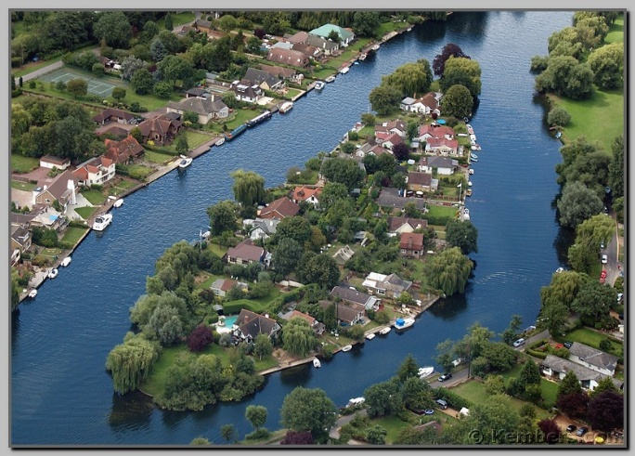
Key Vocabulary
Physical features like seas, mountains and rivers are natural. They would be here even if there were no people around.
Examples of physical geography include natural earth processes, major landforms and environmental systems.
Human features are things like houses, roads and bridges. They have been built by people.
Examples of human geography include settlements, economic activity and resource distribution.
Rural | Relating to the countryside rather than the town or city.
Urban | Relating to or located in a city or town.
Export | Any good or service produced in one country and sold to a buyer in another country.
Fault line | A break or fracture in the Earth's crust where blocks of rock move past each other.
Climate zone | A large geographic region of Earth defined by similar long-term weather patterns, average temperatures, and precipitation levels.
Settlement | A place where people live.
Prairie | A large, mostly flat or rolling area of land in North America that has rich soil, few trees, and is covered mostly by grass and wildflowers.
Plains | Large, flat areas of land with little change in elevation.
Peninsula | A piece of land that is surrounded by water on three sides while remaining connected to a larger mainland on the fourth side.
Distribution | Tthe act of sharing, spreading, or delivering something among people or across an area.
Plate boundary | The bordering edge or zone where two or more massive slabs of the Earth's crust, known as tectonic plates, meet and interact.
Strike-slip fault line | A place where two tectonic plates slide horizontally past each other.

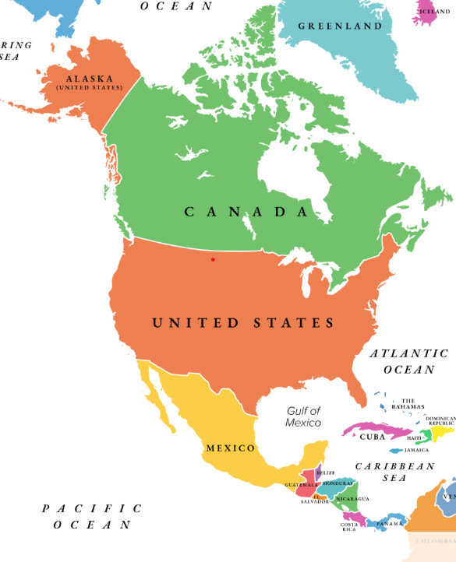
Weather is the day-to-day conditions of the atmosphere.
Climate is a long-term pattern of weather which happens over many years in a specific area.

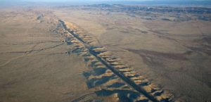
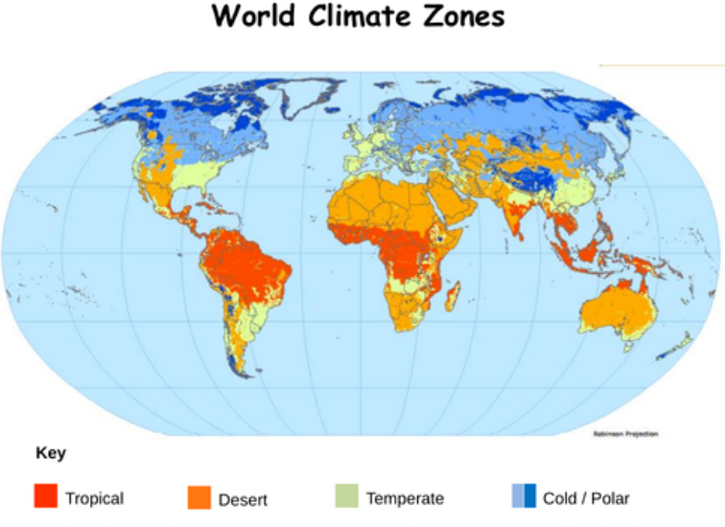
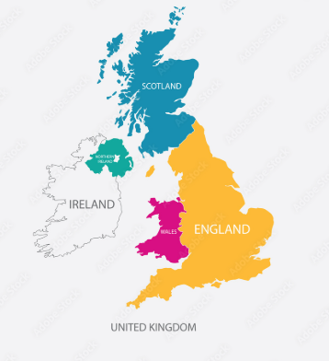
Key Knowledge
- To identify North America and the UK on a world map
- To name some major cities within the UK and North America
- To understand human and physical geography and the differences between the two
- To identify different human and physical features in North America and the UK.
- To compare climate zones between North America and the UK
- To investigate natural disasters and how these affect North America
- To understand what the San Andreas fault is.
The San Andreas Fault is a very long crack in the Earth's crust in California. It stretches for about 1,200 kilometers (750 miles) through the state. This fault is the boundary where two huge pieces of the Earth's crust, called tectonic plates, meet. These are the Pacific Plate and the North American Plate. The plates slide past each other sideways, which is why it's called a transform fault.

