|  |  |
| --- | --- |
| Key Vocabulary | |
| Air Raid Shelter | A building to protect people from bombs dropped by planes. |
| Allies | Countries which fought on the British side (including USA, Great Britain, France). |
| Axis | Countries which fought on the German side (including Italy, Japan). |
| Black Out | System ensuring no lights were visible after dark so that buildings could not be spotted by enemy planes. |
| Blitz | Series of aerial bombing raids on the UK, mainly cities including Nottingham, London and Birmingham. |
| Blitzkrieg | Translated as ‘lightning strike’. German quick strike invasion of Western Europe. |
| Enigma | A machine used by the Nazi’s to send coded messages. |
| Evacuee | Someone who was evacuated, moved from a danger area to a safer place (normally from cities to rural areas). |
| Fascism | Right wing political view associated with not allowing opposition and total control by a dictator. |
| Holocaust | Mass murder of Jews and other groups of people by the Nazi’s. |
| Nazi | Member of the fascist German political party which came to power in 1933. |
| Rationing | The controlled distribution of scarce resources (mainly food and clothing). |

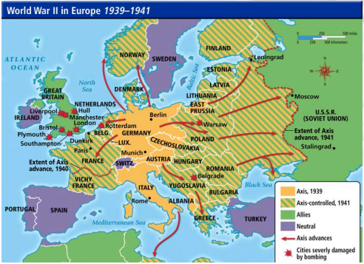

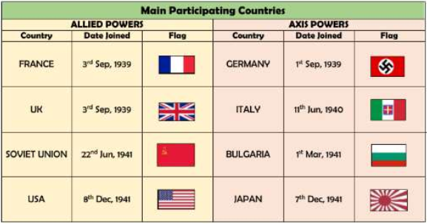

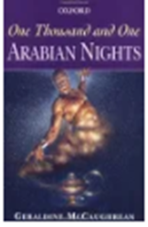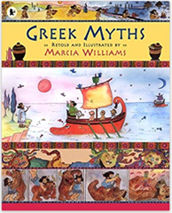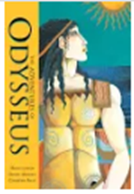

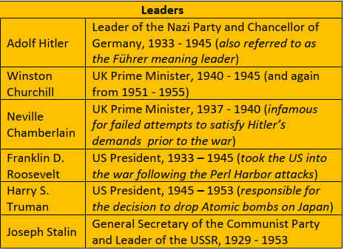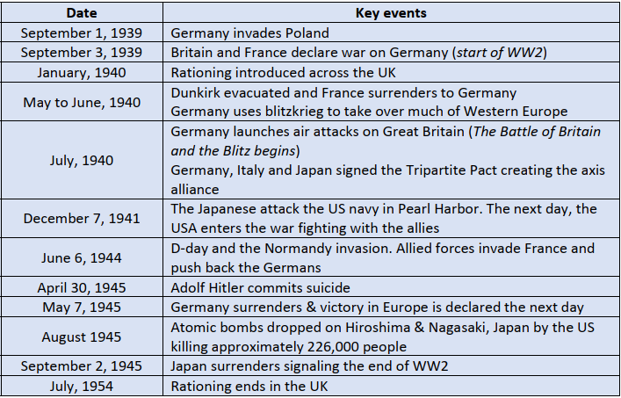



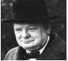

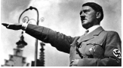

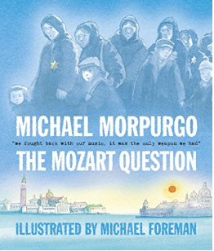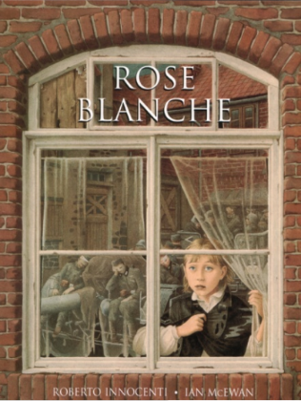**Key texts:**

**Assessment**

* To identify the causes of WWII
* To explore the key events and key people of World War II
* To understand why and where children were evacuated to
* To recognise the significance of the Battle of Britain
* To understand the impact of the Blitz
* To know what people ate and why food was rationed in WWII
* To explore what roles men and women fulfilled; in particular the role women played in the war effort
* To understand how life changed during WWII
* To understand what changes took place as a result of the war