Key Vocabulary
Astronaut | A person trained to take part in space flight.
Famous | Well-known and celebrated by many people.
Space | The vast area beyond Earth, where stars, planets, and other celestial bodies exist.
Space Station | A large spacecraft that remains in low Earth orbit and is used for research and living.
Tourist | A person who is visiting a place for pleasure and interest
Travel | When you go from one place to  another, often to a place that is far away.
Evidence | Information or proof that helps to show something is true or has happened.
Tim Peake | A British astronaut who flew to the International Space Station in 2015.

Timeline of Events
1947 | First animals sent to space. They were fruit flies sent on corn.
1949 | The first monkey is sent to space.
1955 | The Space Race begins between Russia and America
1957 | The first animal goes around the Earth in space. It is a dog named Laika.
1961 | First man in space. His name was Yuri Gagarin
1963 | First woman in space. Her name was Valentina Tereshkova
1969 | Moon Landing.  Neil Armstrong and Buzz Aldrin become the first people to walk on the moon. The first words they said were, “The Eagle has landed.”
1991 | Helen Sharman becomes the first British astronaut in space.
2001 | First space tourist.
2015 | Scientists find evidence of water on Mars.
2015 | Tim Peake became the first British astronaut to visit the International Space Station.

People (and dogs!) of interest
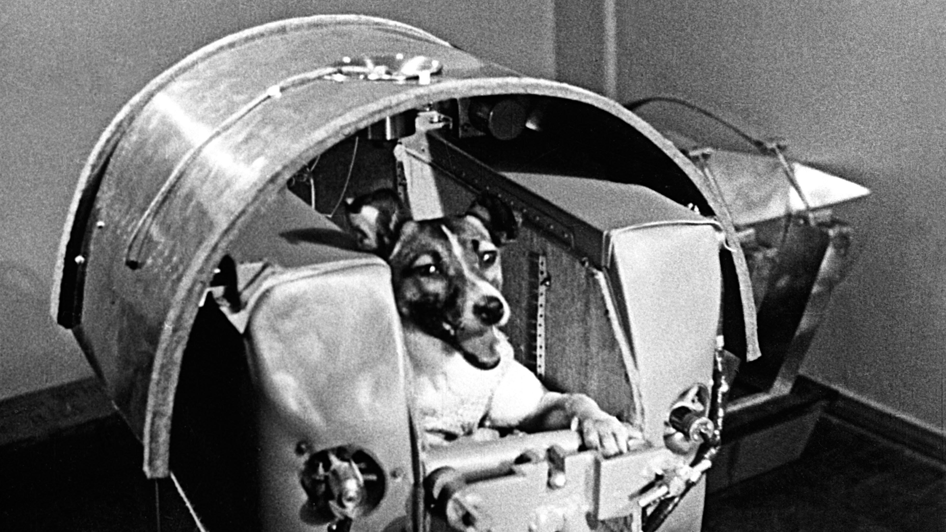
Laika the astronaut
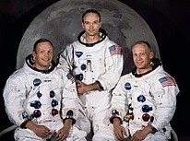
The Apollo 11 crew
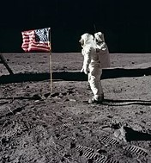
Neil Armstrong
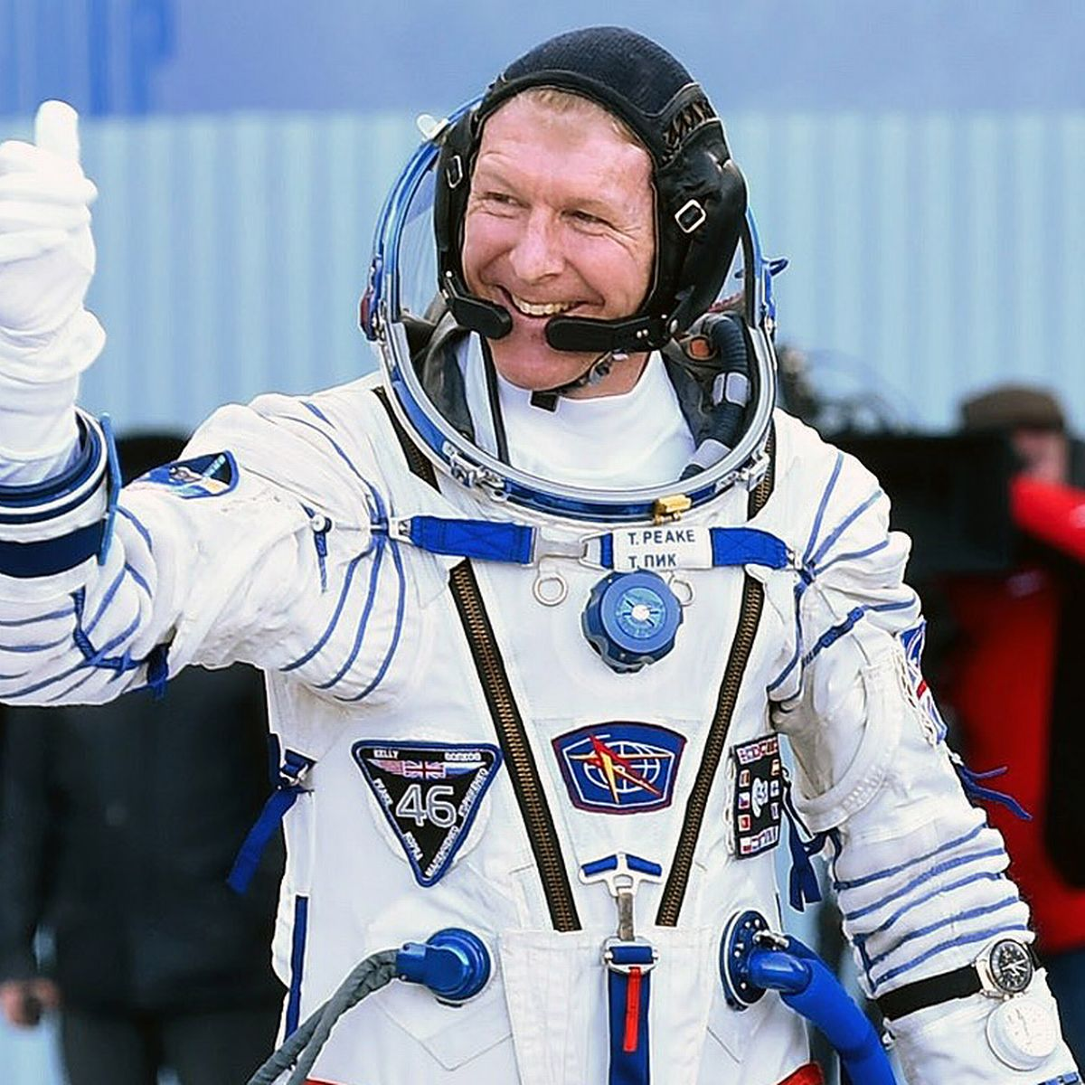
Tim Peake

Assessment
- I can place key events in the history of space in a timeline.
- I can find out about the life of Laika the Space Dog.
- I can explore planets in our Solar System.
- I can understand the life of Neil Armstrong.
- I can recognise Tim Peake and his contributions to space travel.
- I can explain what we know about the 1969 moon landing and its effect on history.
- I can use a range of sources to answer questions.
- I can judge a sources’ reliability.

EYFS LINKS
Communication and Language: Listening, Attention and Understanding.
Learn new vocabulary
Use new vocabulary through the day
Ask questions to find out more and to check they understand what has been said to them.
Articulate their ideas and thoughts in well-formed sentences.
Connect one idea or action to another using a range of connectives.
Describe events in some detail
Use talk to help work out problems and organise thinking and activities explain why they might happen.

Understanding the World: Past and Present
Talk about the lives of the people around them and their roles in society.
Know some similarities and differences between things in the past and now, drawing on their experiences and what has been read in class.
Understand the past through settings, characters and events encountered in books read in class and storytelling.

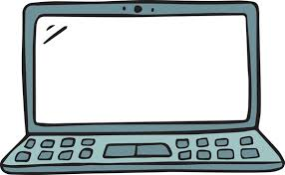
Useful Websites:
- NASA Kids’ Club: Interactive games and activities about space and astronauts.
- National Geographic Kids - Space: Articles and videos about space exploration and discoveries.
- BBC Bitesize - Space: Educational resources and videos about space and famous astronauts.

Interesting fact:
- The first living creature in space was a dog named Laika in 1957.



