|  |  |
| --- | --- |
| **Key Vocabulary** | |
| **Mountain** | A part of the landscape with steep slopes that rises over 300m. |
| **Range** | A series of mountains that form a chain joined by high ground. |
| **Volcano** | An opening in the Earth’s crust that allows molten rock from beneath the crust to reach the surface. |
| **Tectonic plates** | Large pieces of rock that make up the earth’s surface. |
| **Climate** | The weather conditions in an area in general. |
| **Environmental** | The natural world and the impact of human activity on its condition. |
| **Tourism** | People travelling for enjoyment. |
| **River** | A flow of fresh water across the land into a lake, sea or ocean. |
| **Pollution** | A substance in the environment that has harmful or poisonous effects. |
| **Hydrologic cycle** | The way in which water moves around the world. |
| **Condensation** | The process of a gas cooling and changing into a liquid. |
| **Transpiration** | The process where plants absorb water through the roots and then give off water vapour through their leaves. |
| **Evaporation** | The process of a liquid heating and changing into a gas. |
| **Precipitation** | When water or snow falls from a cloud. |
| **Source** | The start of a river. |
| **Mouth** | The end of a river, where it enters a lake, sea or ocean. |
| **Meander** | A large bend in a river. |
| **Tributary** | A small river which flows into a larger river. |
| **Delta** | An area of low land where a river splits and spreads into several branches before entering the sea. |



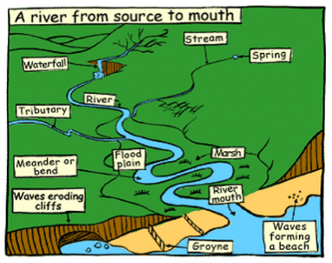

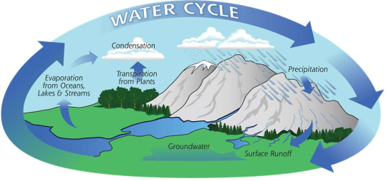

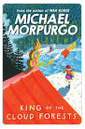

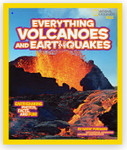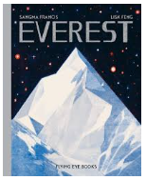

**Key texts:**

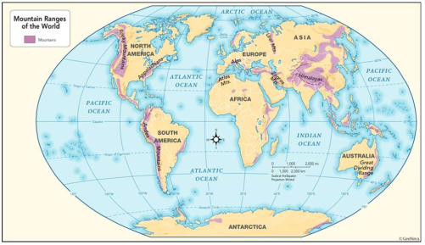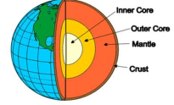****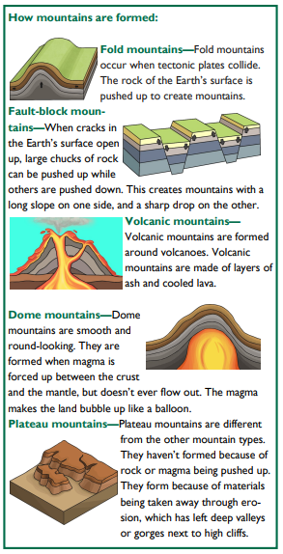

**Assessment**

* To use an atlas to locate the major mountain ranges
* To research a famous mountain
* To find out about mountain climates
* To investigate a mountain environment
* To investigate mountains as tourist destinations
* To know how mountains are formed
* To explain how mountains are formed or why volcanoes erupt
* To find out the positive and negative effects of tourism in mountain environments
* To explain the water cycle in relation to rivers
* To find out how rivers erode, transport and deposit materials
* To identify and research an important aspect of rivers
* To find out about the causes of river pollution and its effect on the environment
* To investigate a river in detail including the effects on the environment and landscape