KS1 How does celebrating Pentecost remind Christians that God is with them always?
What should we be able to do?
Retell parts of the Ascension and Pentecost story.
Describe the Holy Spirit as a helper or friend.
Describe some of the ways Pentecost celebrated in a church.

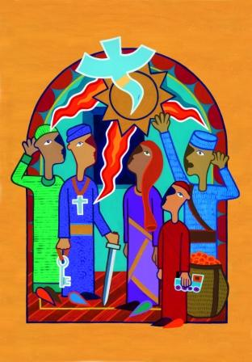
What should we know?
Christians believe:
- When Jesus returned to heaven he promised to send a helper.
- The helper was the Holy Spirit who arrived at Pentecost.
- The Holy Spirit is like an invisible friend who reminds us God is with us always.
- Pentecost is a celebration of the birthday of the church.
- The Holy Spirit makes us more like Jesus.
Prior learning:
God is a VIP.
Jesus is God’s son. He told parables to teach about God.
Everyone is welcome into the Christian family.
Christians pray to God and worship him in different ways.

‘The Lord is here…His Spirit is with us’.

What words should we understand and be able to use?
Pentecost | The day when the Holy Spirit arrived. | Ascension | When Jesus went up to heaven.
Holy Spirit | An invisible helper Jesus sent.

