Key Vocabulary
Industrialisation | The process of using machines to mass produce goods in factories once made by skilled workers (artisans)
Urbanisation | When large numbers of people move from the countryside to the cities to work in the factories. The size of towns and cities grow rapidly.
Monarch | A sovereign head of state, especially a king, queen or emperor
Slums | Overcrowded, dirty city streets where poor factory workers lived in ‘back-to-back’ houses.
Cholera | A killer disease of the 19th Century caused by drinking water contaminated with human waste.
Workhouse | Where people who had no job were sent. It was like a prison with uniforms, boring jobs and harsh rules.
Steam power | Creating steam to power engines and machinery.
Census | A count of all the people in the country on a particular day.
Domestic service | To do household work such as cleaning and cooking in someone else's house
Factory acts | Laws passed by government to protect people working in dangerous factories (particularly women and children).
Leisure | Holidays and other fun activities which people do when they are not working.
Ragged schools | A school set up to teach poor children.
Reformer | A person who makes changes in order to improve things.
Reign | The length of time a king or queen rules a country.
British Empire | Lands that Britain controlled all over the world (for example, India).
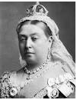

Victoria was the Queen of the United Kingdom of Great Britain and Ireland from 20th June 1837 until 22nd January 1901. On 1st May 1876 she was granted the additional title of ‘Empress of India’. Her reign of 63 years and 7 months was the longest of any British monarch aside from Queen Elizabeth II, and this period was known as the Victorian era. She married her cousin Prince Albert of Saxe-Coburg and Gotha in 1840 – their nine children married into noble families all across Europe, earning her the nickname ‘the grandmother of Europe’. When Albert died in 1861, Victoria sank into deep mourning. She died in 1901 at the age of 81.

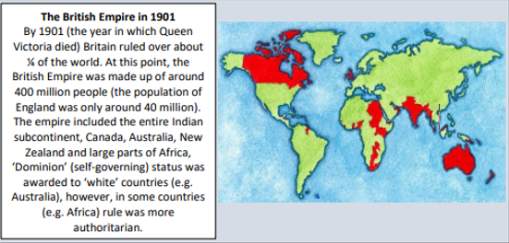

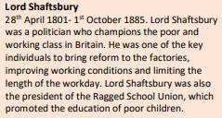

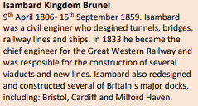

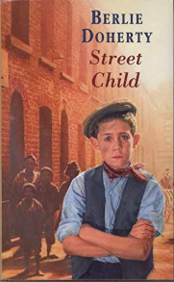
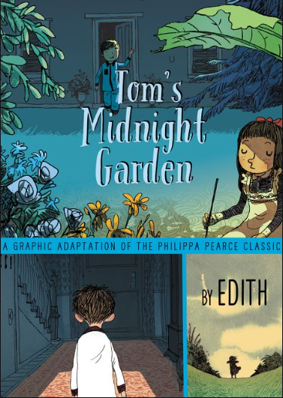
Key texts:
Key Knowledge
- To place the Victorian period within the history of the UK
- To explore the life of Queen Victoria
- To discover important inventions of the Victorian era
- To find out what the Industrial Revolution was and how it affected Britain
- To discover what life was like for poor children including work, education and play
- To find out about health, disease and medicine in Victorian Britain
- To explore what Victorians did during their leisure time
- To study the key social reformers – Shaftesbury and Barnardo
- To find out about the past from census returns within the locality
- To identify changes in the locality within the Victorian period

