Key Vocabulary
Assessment

- To sort items by material and colour.
- To use a variety of materials to create paths and walls.
- To select materials and make spirals or circles.
- To manipulate materials when creating sculptures.
- To use reflections in art work.

Materials | What things are made from.
Patterns | Is a design in which lines, shapes, forms or colour are repeated.
Shading | Is the darkening or colouring in the drawing with lines or blocks of colour.
texture | How something feels when we touch it.
Man Made | Something that does not occur naturally in the world around us.
Natural | The original form of an object found in nature.
Sculptures | An artistic form in which materials create a three dimensional art object.
Artist | A person that creates paintings or drawings as a profession or hobby.
Andy Goldsworthy | Is a famous English Sculptor.

Andy Goldsworthy
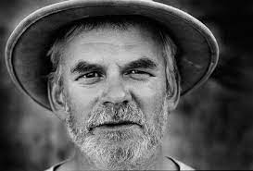

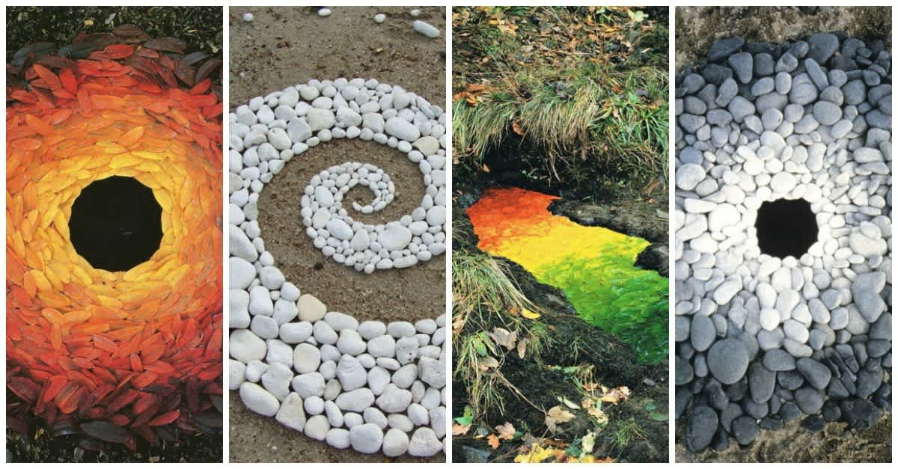
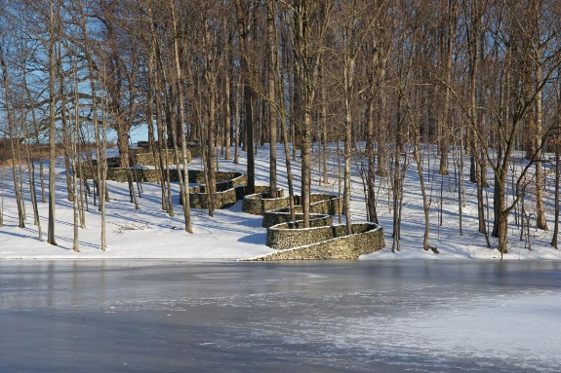
Born: 25 July 1956
Style/Period: English sculptor, photographer, and environmentalist
Famous Works: Storm King Wall (1997-1998)

