Key Vocabulary
absorbent | If something is absorbent, it soaks liquid up
bendy | Bendy things can be bent easily into a curved or folded shape.
dull | Doesn’t reflect light. Doesn’t look bright or shiny.
hard | Not easily broken or bent.
material | Materials are what an object is made from
not absorbent | If something is not absorbent, it does not soak up liquid.
not bendy | If something is not bendy, it can’t be bent easily into a curved or folded shape.
not waterproof | Not waterproof materials let water in.
object | A thing that can be used. For example a door, chair, car, table are all objects.
opaque | Opaque objects can’t be seen through.
rigid | Not able to be bent or moved.
rough | If something is rough, it feels and looks uneven or bumpy.
shiny | Reflects light easily.
smooth | Smooth objects have no lumps or bumps.
soft | If something is soft, it is easy to cut, fold or change the shape of.
stretchy | Can be pulled to make it longer or wider without breaking.
strong | Not easily broken.
transparent | Transparent objects can be seen through
waterproof | If something is waterproof, it keeps water out. It keeps things dry.

Knowledge Outcomes:

Everyday Materials

- I can sort wood, plastic, glass and metal objects and sort them into different categories.
- I can sort different objects into groups based on their properties such as shiny or dull.
- To explore the differences between objects and the materials they are made from.
- To observe how some materials melt and freeze.
- To explore different materials to see whether they float or sink when placed in water.
- I can carry out a simple comparative test to explore which materials are able to absorb water.

Working Scientifically
- I can ask simple questions and recognising that they can be answered in different ways.
- I can observe closely, using simple equipment.
- I can perform simple tests.
- I can identify and classify.
- I can use observations and ideas to suggest answers to questions.
- I can gather and record data to help in answering questions.

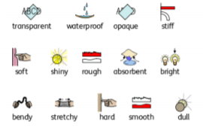

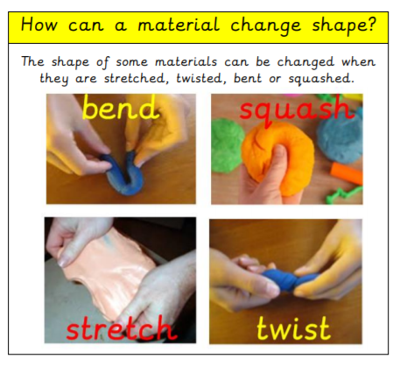
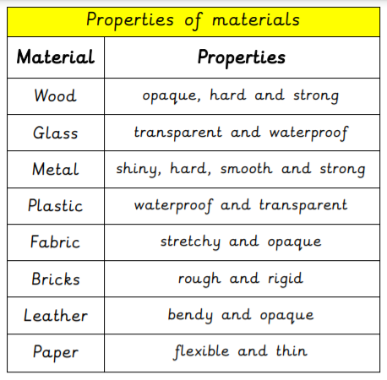
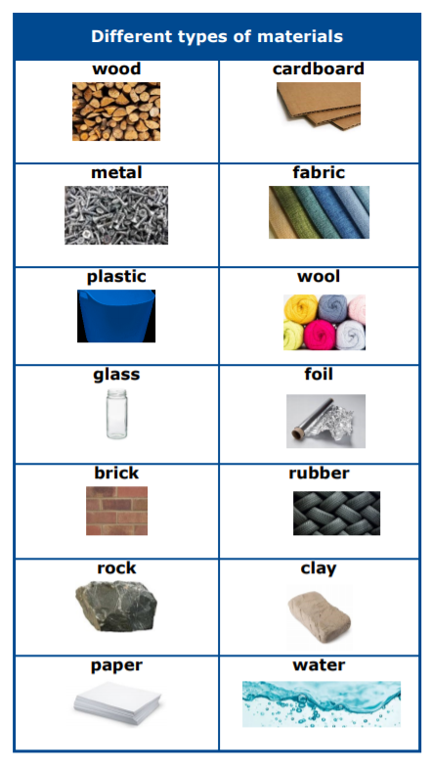

EYFS LINKS
Communication and Language: Listening, Attention and Understanding. | Expressive Arts and Design: Creating with materials.  Safely use and explore a variety of materials, tools and techniques, experimenting with colour, design, texture, form and function.  Understanding the World:: The Natural World  Explore the natural world around them, making observations and drawing pictures.  Know some similarities and differences between the natural world around them.  Understand some important processes and changes in the natural world around them, including changing states of matter.
  Learn new vocabulary
  Use new vocabulary through the day
  Ask questions to find out more and to check they understand what has been said to them.
  Articulate their ideas and thoughts in well-formed sentences.
  Connect one idea or action to another using a range of connectives.
  Describe events in some detail
  Use talk to help work out problems and organise thinking and activities explain why they might happen.

