Key Vocabulary
Cliff | A steep rock face, often found by the sea.
Forest | A large area covered with trees.
Mountain | A very high area of land, often with steep sides.
Valley | A low area of land between hills or mountains.
Flora | The plants of a particular region or habitat.
Fauna | The animals of a particular region or habitat.
Habitat | The natural home or environment of an animal, plant, or other organism.
Coral | A marine invertebrate that builds reefs in the sea.
Reef | A ridge of rock or coral near the surface of the sea.
City | A large town with many buildings and people.
Town | A smaller area than a city, with its own local government.
Village | A small community in a rural area.

Knowledge Outcomes:
Where is the World is Slindon?
- To locate Slindon on a UK map.
- To observe and identify physical and human features in the school and village.
- To draw a simple map using symbols and a key.
Where in the World is Australia?
- To locate Australia on a world map.
- To know that Australia is a continent and a country.
- To identify major cities and the capital city.
Where is Sydney?
- To locate Sydney and identify it as a major city.
- To recognise famous landmarks in Sydney.
- To compare a city (Sydney) with a village (Slindon).
Slindon vs Cairns (Coastal City Near the Reef)
- To identify human and physical features in a coastal city near the Great Barrier Reef (Cairns).
- To compare these with human and physical features in Slindon.
- To use simple maps and photos to describe differences.
Temperature and Weather: Slindon vs Great Barrier Reef
- To compare temperature and weather patterns in Slindon and Queensland.
- To use pictures/temperature cards to describe hot and cold climates.
Flora and Fauna: What Lives in Slindon and the Great Barrier Reef?
- To identify plants and animals found in Slindon.
- To identify plants and animals found in the Great Barrier Reef.
- To recognise differences in habitats.

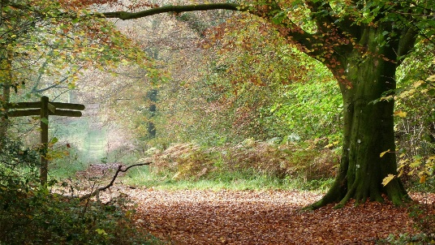
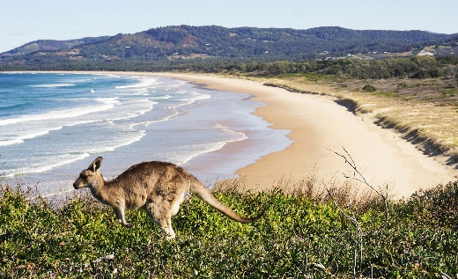

EYFS LINKS
Communication and Language: Listening, Attention and Understanding
Learn new vocabulary
Use new vocabulary through the day
Ask questions to find out more and to check they understand what has been said to them.
Articulate their ideas and thoughts in well-formed sentences.
Connect one idea or action to another using a range of connectives.
Describe events in some detail
Use talk to help work out problems and organise thinking and activities explain why they might happen.

Understanding the World: The Natural World
Explore the natural world around them, making observations.
Know some similarities and differences between the natural world around them and contrasting environments, drawing on their experiences and what has been read in class.
Understand some important processes and changes in the natural world around them, including life cycles.


Interesting Facts
- The Great Barrier Reef in Australia is the largest coral reef system in the world.
- The koala and kangaroo are native animals found in Australia, whereas Slindon is home to hedgehogs and rabbits.

Useful Websites
- BBC Bitesize: Offers interactive lessons on maps and geography.
- National Geographic Kids: Provides information about Australia, including its cities and wildlife.
- Geography for Kids: A resource for learning about different countries, including Australia.
- Google Earth: An interactive tool to explore maps and geographical features around the world.



