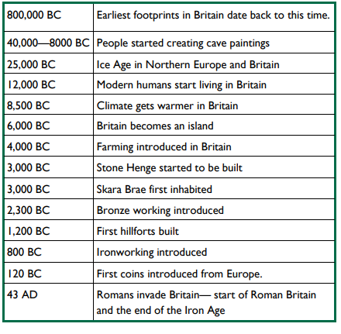**Key Dates:**

**What will I know by the end of the unit?**

* Why it is the Stone. Bronze and Iron Age
* To identify changes and continuity between periods of history
* To identify the difference between a primary and secondary source
* To be able to compare settlements and technology from each period of history

**The Stone Age**

The Stone Age is a period of our history that happened thousands of years ago. It is called the **Stone Age** because it is the era when early humans started using stone for **tools and weapons**. They also used stones to light fires. The Stone Age is divided into three periods; the **Palaeolithic** (old Stone Age), **Mesolithic** (middle Stone Age) and the **Neolithic** (new Stone Age). Palaeolithic and Mesolithic people were **hunter gatherers**. They moved frequently following the animals they hunted and gathered fruits and berries when they could.

**The Bronze Age**

During the Bronze Age, people developed the **technology** to make bronze. This was used to make bronze **tools**, containers and jewellery. There was a lot of **migration** to Britain during this period. Some of the people who arrived in Britain were from Central Europe and were called the ‘Beaker People’. They are known for the distinctive bell-shaped pottery they made, mainly used for drinking from. It is likely, but not certain, that the Beaker People brought their knowledge of making bronze to Britain and that is how the Bronze Age in Britain started.

**The Iron Age**

During the Iron Age**, technology** developed further across many aspects of life. People began to make tools and **weapons** from **iron**. Again, many of the new ideas came with the migration of people. People who lived at this time are now often called **‘Celts’**. Celts were **farmers** and lived as part of a **tribe**. Hillforts developed during the Iron Age. Communities lived on hills for protection from when other tribes attacked.



