Slindon Church of England Primary School

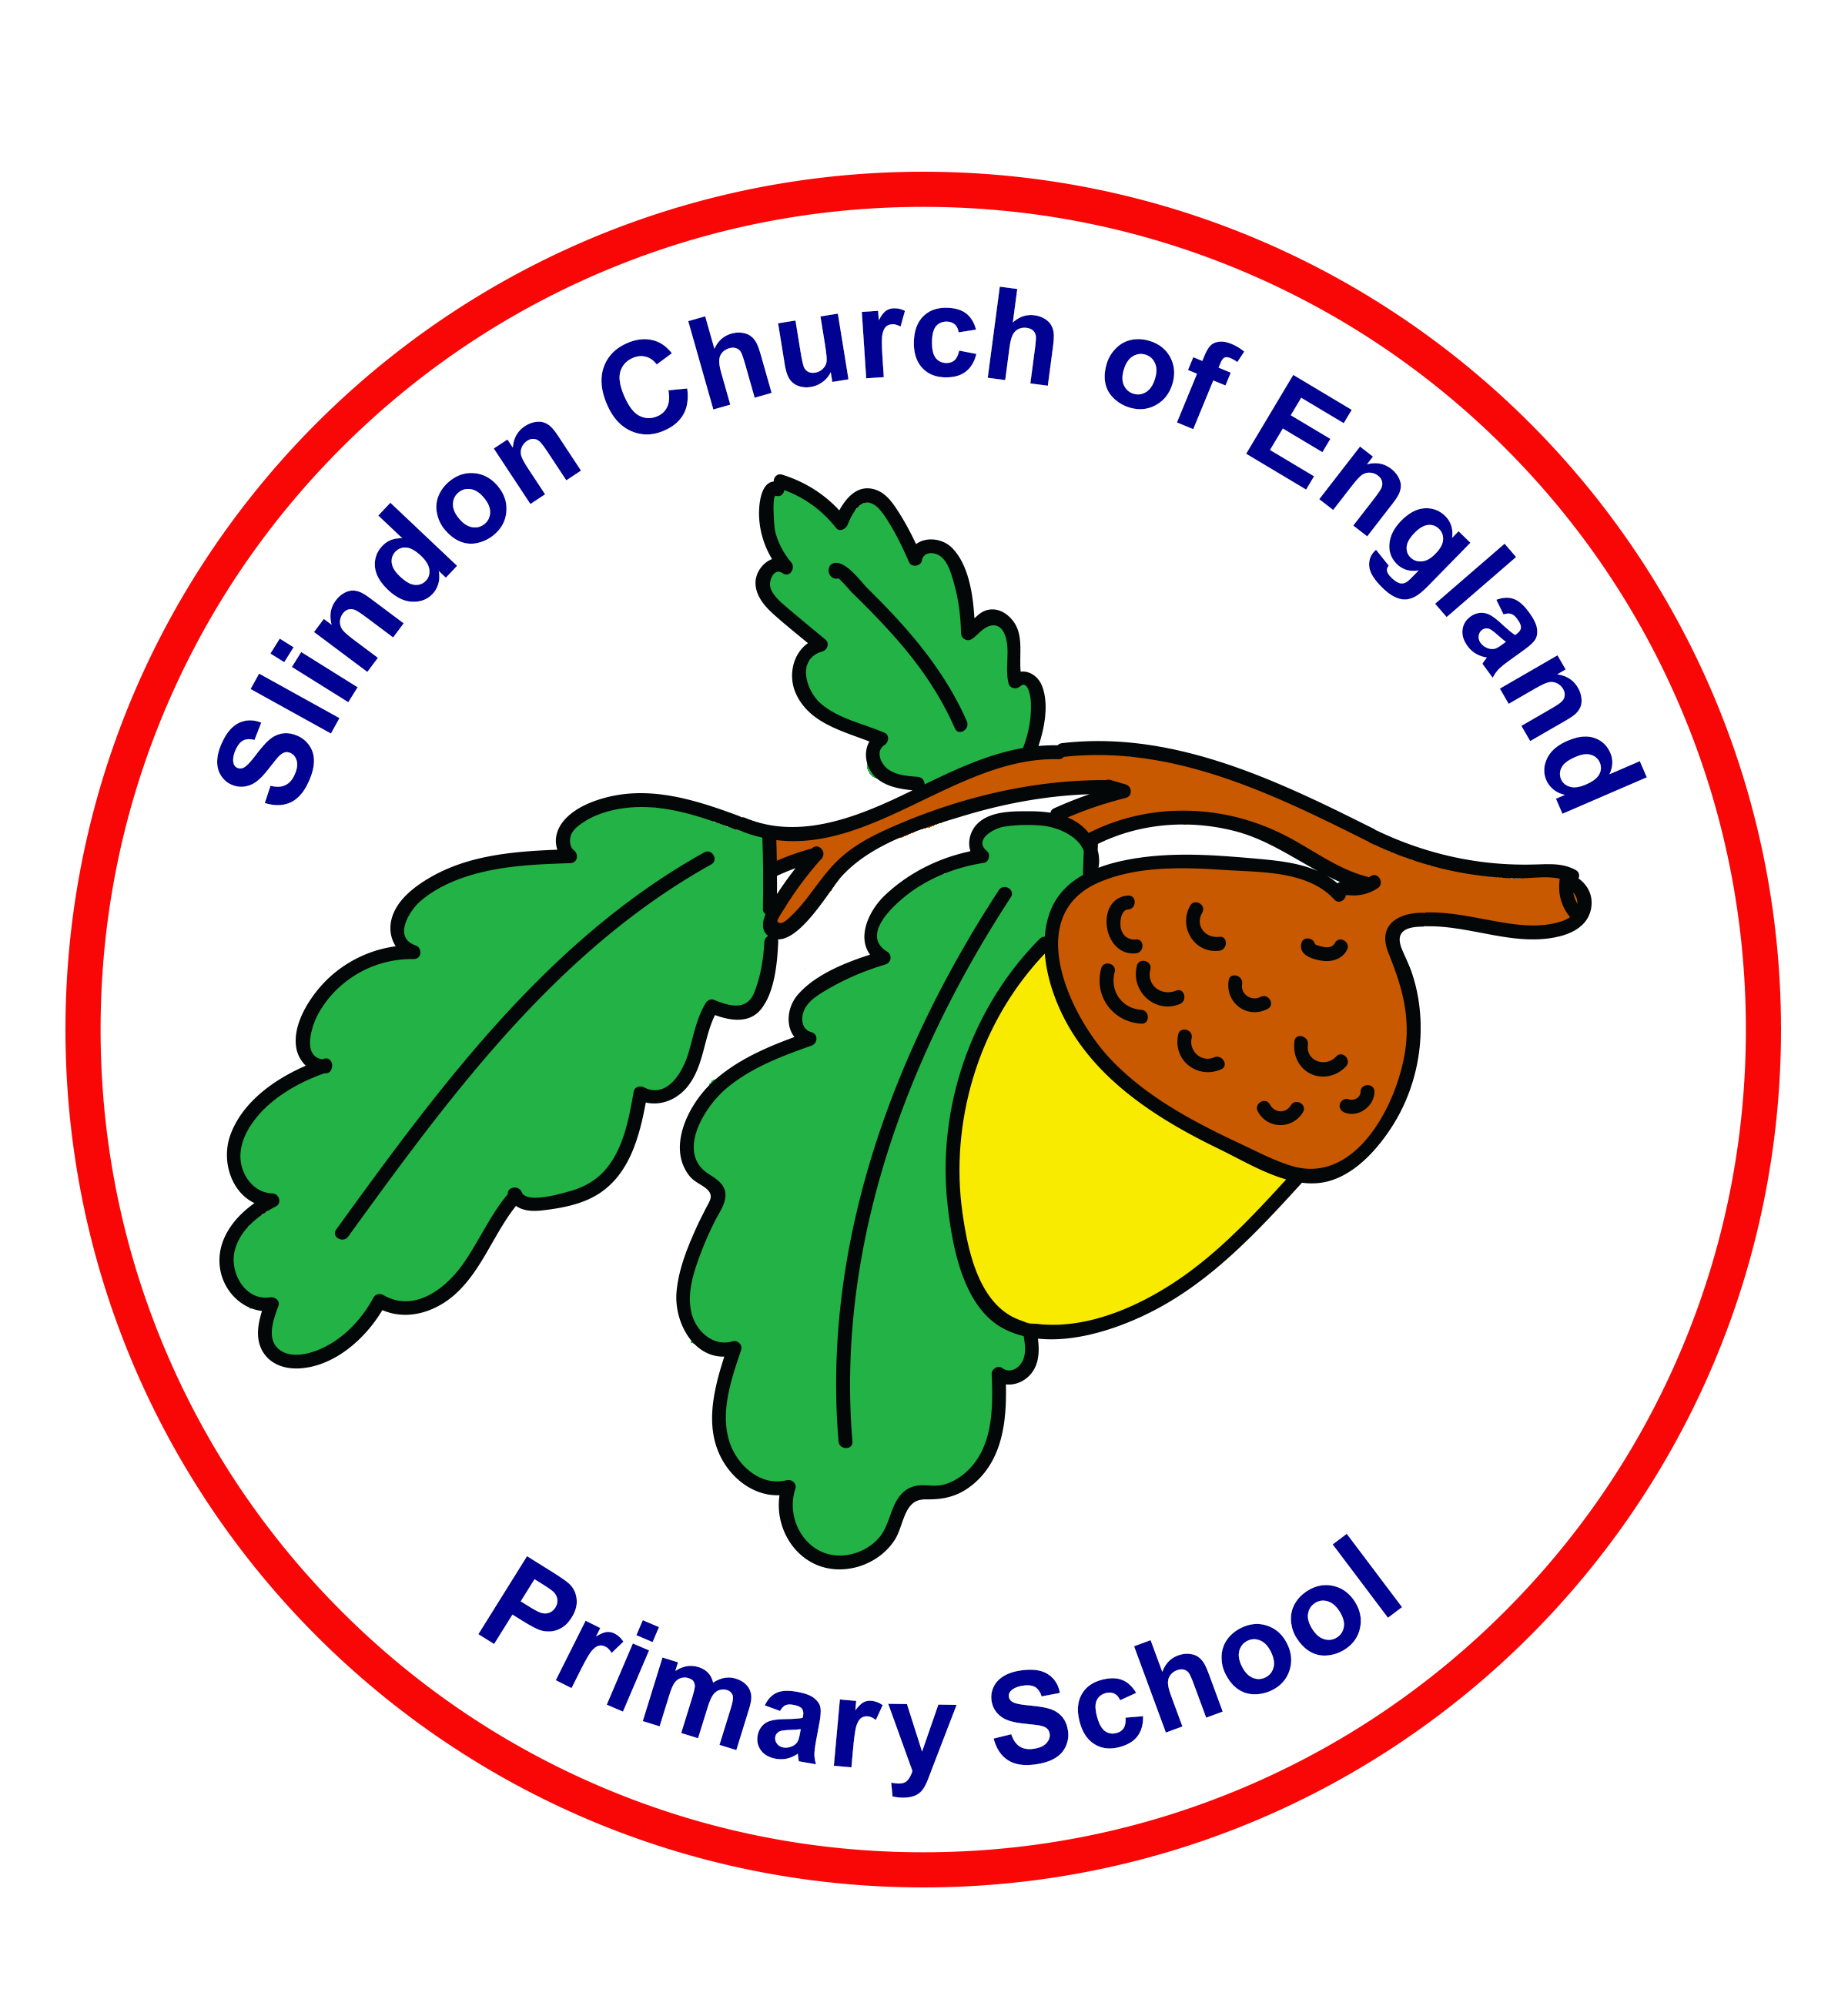

Reading Policy

Approved by: | Headteacher (Laura Webb)
Date: | 12th October 2022
Last reviewed on: | February 2026
Next review due by: | February 2027

Vision Statement

At Slindon CofE Primary school we serve our local community and enable our school family to flourish. We recognise that everyone is Unique and want to ensure they are able to Learn and Develop in a high quality learning environment. We enrich the spirit in an Enabling Environment, in which Positive Relationships foster creativity and curiosity. In hope we encourage our community to shine brightly and be courageous advocates of our world, shaping their futures for the better.

The Fruit of the Spirit is love, joy, peace, patience, kindness, goodness, faithfulness, gentleness and self-control; against such things there is no law.

Galatians 5; 22-23

Let Your Light Shine ~ Matthew 5:16

Intent of our reading curriculum

At Slindon Church of England Primary School, we have a thirst for reading and fully recognise the intrinsic role it plays within our approach to teaching and learning. A huge emphasis is therefore placed on reading at every possible opportunity, whether the pupils are at home or in school. It is our aim to develop and create passionate readers for life.
At our school, we recognise the importance of reading as an essential life skill, that provides access to the experiences of people from different cultures and times. Children must acquire good reading skills to access the information that will support their development in all curriculum areas and to be able to flourish in their learning.

Aims and Objectives of our reading curriculum

In line with the aims of the National Curriculum for reading, through our delivery of our reading curriculum, we aim to ensure that our pupils can:
- Read easily, fluently and with good understanding.
- Develop the habit of reading widely and often, for both pleasure and information.
- Acquire a wide vocabulary, an understanding of grammar and knowledge of linguistic conventions for reading, writing and spoken language.
- Appreciate our rich and varied literary heritage.

Approach

Our school identifies two important phases in reading development: learning to read and reading to learn. A range of teaching strategies are employed that recognise children’s needs in each phase.

- Reading to/with the children either individually, in small groups or as a whole class through planned guided or shared reading activities. We are very lucky to have parent volunteers who come in to read with individual children.
- Telling our children stories – building their imagination and vocabulary through opportunities such as our ‘Open the Book’ assemblies.
- Celebrating the opportunities of mixed-age classes with older pupils reading to younger pupils – encouraging reading for pleasure.
- Reading across the curriculum – our exciting and engaging curriculum ensures that all opportunities for reading are meaningful and relevant and interesting (and often outside of the classroom!)
- Reading a comic, a magazine or an appropriate newspaper- Key Stage 2 children love to receive their weekly newspaper copy of ‘First News’ to keep up with what is happening in the world.

Reading at Slindon Church of England Primary School takes place throughout the curriculum where children are encouraged to apply the skills they have been taught in focused reading lessons, such as Guided Reading.
Teaching in Guided Reading sessions focuses on developing pupils’ competence in both word reading and comprehension as outlined in the National Curriculum Programmes of Study for Reading.
In Key Stage 1, Guided Reading takes place as a whole year group in Year 2. In Key Stage 2, where the children are more competent in their reading abilities, whole class Guided Reading takes place.

Skilled word reading involves both the speedy decoding of unfamiliar printed words and the speedy recognition of familiar printed words. Underpinning both is the understanding that the letters on the page represent the sounds in spoken words.
This is why, at our school, a Systematic Synthetic Phonics (SSP) approach is emphasised in the early teaching of reading to secure independent decoding and we use the principles of the Phonics Shed SSP programme to achieve this.
Reading scheme material, produced by Phonics Shed, is used for children mastering decoding skills. These texts are supplemented by a broader range of graded reading materials that provide access to different sentence structures, lay-out and styles of writing. Home-school reading materials are drawn from a range of reading schemes, along with books to be read to the children for pleasure. Children will bring home a book to match their current learning.

Children in Key Stage 1 are expected to read at home to an adult daily. This is recorded within the Reading Record and monitored by the class teacher (see Home Learning Schedule).
Children in Key Stage 2 are expected to read at home independently/ to an adult 5 times per week.

Reading Curriculum in EYFS and Key Stage 1

Word reading is initially taught through phonics (Grapheme-Phoneme Correspondence) using the principles from the Phonics Shed scheme. Phonics teaching focuses on phoneme/grapheme recognition and the strategies of blending to read and segmenting to spell. This underpins the teaching of early reading. Regular assessment ensures children receive active intervention support, where necessary.

The children are encouraged to acquire a love of books and to develop a respect for them. We aim to use books to stimulate the child’s imagination. Children are introduced to the conventions of books, left to right, regarding the illustrations as an integral part of the story, turning the pages singly etc.

Each child takes home an appropriately selected book from our chosen SSP scheme, Phonics Shed. The children share their books with an appropriate adult several times a week. The adult asks questions relevant to the interest of the child and encourages predictions. The children are encouraged to decode unknown words using appropriate strategies.

Children in the EYFS, Year 1 and Year 2 are taught to read and spell the appropriate Common Exception Words for their year group, to support them in their early reading.

In Year 2 when the children are secure in phonics, they follow the Spelling Shed programme which allows them to learn new spelling rules and patterns. They will then move on to more challenging texts to continue to support their reading development.

A ‘Class Book’ is used to encourage children’s enjoyment of literature across the curriculum. This is read every day and is used as a stimulus or ‘hook’ for the planned learning across different subjects within the curriculum.
During Year 2, whole class guided reading is taught to ensure that texts are appropriate to each important phase of the early reading journey.

Reading Curriculum in Key Stage 2

In Key Stage 2, a greater emphasis is placed on reading comprehension skills, such as understanding of vocabulary, inference, prediction, explanation, information retrieval and summarising skills. Key reading skills are taught through whole class guided reading sessions using ‘Literacy Shed VIPERS’ strategies to reading. During these sessions, children will engage in a wide range of activities including answering questions related to the text, producing artwork to show understanding, comprehension and rewriting parts of the text from a different viewpoint.

Key texts continue to be used in Key Stage 2 to encourage children’s enjoyment of literature. This is used as a stimulus or ‘hook’ for the planned learning across the curriculum.

Children in Key Stage 2 continue to follow the Spelling Shed Programme to help them secure their knowledge of spelling rules and patterns. The teaching of reading and spelling the Common Exception Words appropriate to each year group continues in Key Stage 2.

Inclusion

In alignment with our commitment to inclusivity and recognising that everyone learns and grows uniquely, each child will be given equal opportunities to engage with all aspects of the reading curriculum and the ability to fully participate in reading lessons. Consequently, teachers pay careful attention to accommodating children’s individual learning needs and adapting lessons where needed.

We recognise that in all classes, children have a wide range of reading ability, and so we seek to provide suitable learning opportunities for all children by matching the challenge of the task to the ability of the child. We achieve this in a variety of ways:
• Setting tasks which are open-ended and can have a variety of responses.
• Setting tasks of increasing difficulty.
• Providing resources of different complexity, depending on the ability of the child.

We also use accessibility tools, such as Lightning Squad, to support children with their comprehension of texts.

The teaching of phonics may continue into Key Stage 2, where appropriate. This may be supported with individual targets from an Education and Health Care Plan (EHCP) or from an external agency report such as Speech and Language Therapy. Children are supported individually or in small groups.
Interventions will occur during reading sessions as well as outside of them; these sessions may be led by the teacher or teaching assistant and could involve either individualised or small group work.

Resources

The high status of Reading at our school ensures that we provide high quality, up-to-date resources for teaching reading. The school library is open to pupils throughout the day; all pupils are encouraged to choose a library book from the school library each week.
Each classroom has stimulating and inviting book corners. It is here where real ‘book-talk’ can happen; where children are able to recommend a read to their peers, browse, and choose a book to take home and enjoy. Books in classrooms include topic linked books, class favourites, different styles of books such as annuals, encyclopaedias, magazines, and class-selected reads from our wonderful library.

For pupils who have learned to decode in Key Stage 1 (learning to read), ‘free reader’ books are provided for pupils who have acquired decoding skills beyond those normally expected for pupils at this stage. Books are chosen to reflect the children’s age whilst providing challenge in relation to vocabulary and length of texts.

In Key Stage 2, a set of books is provided for pupils who have acquired the expected decoding skills for their age group. The texts are chosen to provide coverage of a wide range of text types, genres and poetry and to be matched to the ages and maturity of the pupils. Children are encouraged to develop their own reading tastes and to be challenged into trying new types of reading materials. They are expected to learn from what they read; facts and information as well as empathy for characters, situations, and dilemmas that they encounter in narrative texts. At this stage, teachers may allow children to bring suitable reading materials from home, especially where they feel that the child has well developed reading tastes and habits.

We encourage our children to choose a book they would ‘love to read’, recognising the Unique Child, while also carefully monitoring and assessing their reading choices to support their Learning and Development across the reading curriculum. As a school we recognise that reading is fundamental and want children to develop a Positive Relationship with reading. To support this, we endeavour to create Enabling Environments within the school, where the children can sit, enjoy, and discuss their texts.

Assessment and Reporting

Reading is prioritised to allow pupils to access the full curriculum offer and this is reflected in the attainment and progress at the end of the Early Years Foundation Stage (EYFS), Key Stage 1 and Key Stage 2 and the Phonics Screening Check that takes place in Year 1. A rigorous and sequential approach to the reading curriculum develops our pupils’ fluency, confidence, and enjoyment in reading. At all stages, reading attainment is assessed and gaps are addressed quickly and effectively for all pupils.

Regular, ongoing phonics assessments take place throughout the time that children are receiving phonic teaching. Attainment and progress are shared with the Headteacher at the end of each half term. Summative assessments are made through the statutory Phonic Assessment Screening in the Summer term.

In Years 2-6, PIRA assessments take place half termly. Results are shared through termly pupil progress meetings with the headteacher, for strategies and action to facilitate pupil progress to be implemented in a timely manner.

Review and Evaluation

The policy for reading will be revised annually as an agenda item at a staff meeting.
This item will be led by the Headteacher. Comments from staff and governors will be considered and any changes to policy agreed at a staff meeting prior to ratification by the governing body.
The implementation of the policy will be assessed by the Headteacher through monitoring activities. The Headteacher will, if necessary, call on external agencies to give specialist advice.

Links to other policies

- Early Reading and Phonics Policy
- Writing Policy
- Assessment Policy
- Early Years Foundation Stage Policy

