**Slindon Church of England Primary School**

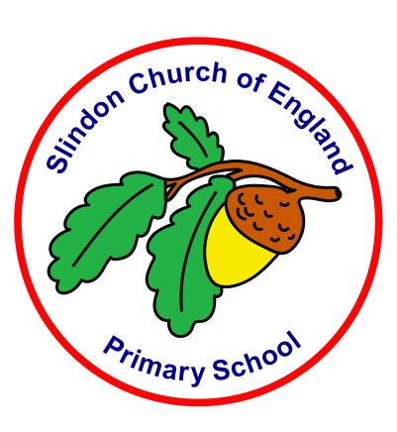

**Social, Moral, Spiritual and Cultural Policy (SMSC)**

|  |  |
| --- | --- |
| **Approved by:** | Headteacher (Laura Webb) and Governing Body |
| **Date:** | October 2022 |
| **Last reviewed on:** | October 2024 |
| **Next review due by:** | October 2025 |

Our Vision:

At Slindon CofE Primary school we serve our local community and enable our school family to flourish. We recognise that everyone is Unique and want to ensure they are able to Learn and Develop in a high quality learning environment. We enrich the spirit in an Enabling Environment, in which Positive relationships foster creativity and curiosity. In hope we encourage our community to shine brightly and be courageous advocates of our world, shaping their futures for the better.

*The Fruit of the Spirit is love, joy, peace, patience, kindness, goodness, faithfulness, gentleness and self-control; against such things there is no law.*

*Galatians 5; 22-23*

*Let Your Light Shine ~ Matthew 5:16*

As a Rights Respecting School, all our policies are underpinned by the United Nations Convention on the Rights of the child.

**Article 2:** The Convention applies to all children, whatever their race, religion or abilities; whatever they think or say, whatever type of family they come from.

**Article 28:** All children have the right to a primary education, which should be free.

Supporting the Spiritual, Moral, Social and Cultural learning of every child in our schools is explored in this policy. Our Christian values underpin all policies in our school.

Our Learning Values also play a vital role in supporting children in knowing that they have a role in the development of their learning and the behaviour that leads to excellent learning. Through consultation with the children, parents, governors and teachers these values have been adopted and play a key role in everything we do.

**Our learning values are:**

**Unique child Learn and develop Enabling environments Positive relationships.**

**Introduction**

As a Church of England school we take our duty to promote the spiritual, moral, social and cultural (SMSC) development of pupils seriously, including the duty to promote British Values. As a Forest School, we ensure that every opportunity is given to sharing the awe and wonder of the natural world, particularly the pieces of woodland that the children know in the local area. We are also a Rights Respecting school, which advocates children’s rights and understanding the rights of others.

Our Church of England school has a distinctive identity and ethos, popular with parents and families, where the development of social, spiritual and emotional intelligence is as important as academic achievement. Our Learning Values and Christian values underpin all of our actions within school. As a rural school, we have to work hard to develop understanding of diversity and difference as our cultural differences are so limited.

**Defining spiritual, moral, social and cultural development**

**The spiritual development of pupils is shown by their:**

* Ability to be reflective about their own beliefs, religious or otherwise, that inform their perspective on life and their interest in and respect for different people’s faiths, feelings and values
* Sense of enjoyment and fascination in learning about themselves, others and the world around them
* Use of imagination and creativity in their learning
* Willingness to reflect on their experiences
* To understand their purpose in life

**The moral development of pupils is shown by their:**

* Ability to recognise the difference between right and wrong and to readily apply this understanding in their own lives, recognise legal boundaries and, in so doing, respect the civil and criminal law of England
* Understanding of the consequences of their behaviour and actions
* Interest in investigating and offering reasoned views about moral and ethical issues and ability to understand and appreciate the viewpoints of others on these issues including using and understanding religious and ethical teachings

**The social development of pupils is shown by their:**

* Use of a range of social skills in different contexts, for example working and socialising with other pupils, including those from different religious, ethnic and socio-economic backgrounds
* Willingness to participate in a variety of communities and social settings, including by volunteering, cooperating well with others and being able to resolve conflicts effectively
* Acceptance and engagement with the fundamental British values of democracy, the rule of law, individual liberty and mutual respect and tolerance of those with different faiths and beliefs; they develop and demonstrate skills and attitudes that will allow them to participate fully in and contribute positively to life in modern Britain.

**The cultural development of pupils is shown by their:**

* Understanding and appreciation of the wide range of cultural influences that have shaped their own heritage and those of others
* Understanding and appreciation of the range of different cultures within school and further afield as an essential element of their preparation for life in modern Britain
* Knowledge of Britain’s democratic parliamentary system and its central role in shaping our history and values, and in continuing to develop Britain
* Willingness to participate in and respond positively to artistic, musical, sporting and cultural opportunities
* Interest in exploring, improving understanding of and showing respect for different faiths and cultural diversity and the extent to which they understand, accept, respect and celebrate diversity, as shown by their tolerance and attitudes towards different religious, ethnic and socio-economic groups in the local, national and global communities

**Principles**

Spiritual, Moral, Social and Cultural Development is crucial for individual pupils and important for society as a whole. It is the heart of what education is all about – helping pupils grow and develop as people and effective participants in modern Britain.

Spiritual, Moral, Social and Cultural Development is cross curricular and promotes the aims and principles of the policies for, Religious Education, Collective Worship, PSHE, RSE, and Equal Opportunities. These policies all underpin the Curriculum model, putting the child at the centre of all we do.

It is an expectation that all staff, in all subjects, can and should make a contribution to the Spiritual, Moral, Social and Cultural Development of pupils through the curriculum and through the use of appropriate teaching and learning strategies e.g. discussion, reflection, pupil participation, circle time and also through their own conduct.