Key Vocabulary
The Gunpowder Plot | A plot to blow up the Houses of Parliament to kill King James I and his government.
Catholics | People who follow the religion of Roman Catholicism, which was not allowed in England during King James I’s rule.
Protestants | People who follow a branch of Christianity, which King James I belonged to; they were the majority in England at that time.
Houses of Parliament | The building in London where the government works.
Gunpowder | An explosive powder that was used in guns.

Knowledge Outcomes:

- I can identify when the Gunpowder Plot happened.
- I can describe who King James I of England was.
- I can explain what Bonfire Night is and why it is celebrated.
- I can discover who Guy Fawkes was and his role in the plot.
- I can outline what happened after the Gunpowder Plot failed.
- I can understand why we light fireworks on November 5th.

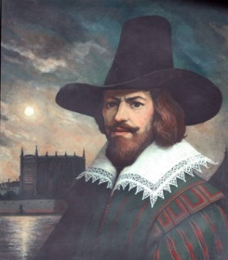


Useful Websites:
- BBC History - Gunpowder Plot: A kid-friendly resource explaining the Gunpowder Plot.
- The British Library - Guy Fawkes: Information and resources about the historical context.
- National Geographic Kids - Bonfire Night: Fun facts and quizzes about Bonfire Night and Guy Fawkes.

Interesting facts:
- Guy Fawkes was caught with 36 barrels of gunpowder.
- Fireworks have been part of Bonfire Night celebrations since 1606, as a way to mark the failure of the plot.



