|  |  |
| --- | --- |
| Key Vocabulary | |
| **Materials** | Substances used to make objects, such as wood, plastic, and fabric |
| **Natural** | Materials that come from the earth, like wood from trees and stone from rocks. |
| **Human-made** | Objects created by people, such as plastic, glass, and metal items. |
| **Recyclable** | Materials that can be processed and used again, like paper and certain plastics. |
| **Transparent** | A property of a material that allows light to pass through clearly, like glass. |
| **Translucent** | A property of a material that allows some light to pass through but not clear images, like frosted glass. |
| **Opaque** | A property of a material that does not let light through, like wood or metal. |
| **Metal** | A hard, shiny material that is usually a good conductor of heat and electricity, like iron and silver. |
| **Fabrics** | Textiles made from threads and fibres, used to make clothing and other items. |
| **Structure** | The arrangement of materials and parts that make up an object. |
| **Properties** | Characteristics of materials, such as texture, colour, hardness, and flexibility. |
| **Test** | An experiment or examination to discover how a material behaves. |
| **Bending** | The action of forcing a material to curve. |
| **Squashing** | The action of pressing a material to make it flatter or smaller. |

 

**Knowledge Outcomes:**

* I can identify objects made from natural, human-made, and recyclable materials.
* I can explain the different properties of materials using the terms transparent, translucent, and opaque.
* I can explore a range of metallic objects and perform simple tests to further understand the properties of metals.
* I can perform a simple test to discover how materials change shape through bending, squashing, twisting, and stretching.
* I can make a prediction about a material’s properties, particularly in relation to water resistance.
* I can use my observation skills to answer questions about the materials that I am investigating.

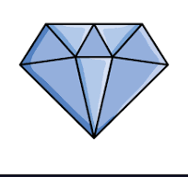

**Useful Websites:**

* [BBC Bitesize Science - Materials](https://www.bbc.co.uk/bitesize/topics/zs4qhyc)
* [National STEM Learning Centre - Materials](https://www.stem.org.uk/resources/elibrary/resource/354400/materials-and-their-properties)
* [Primary Science Teaching Trust - Investigating Materials](https://www.pstt.org.uk/resources/curriculum-materials/)

**Interesting fact!**

The hardest natural material on Earth is **diamond**, which is a form of carbon.

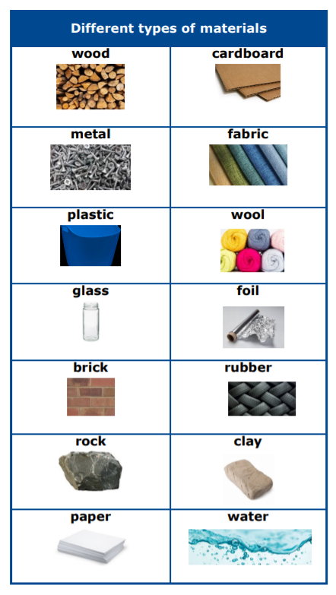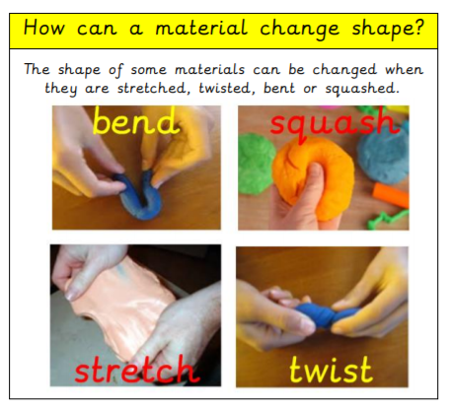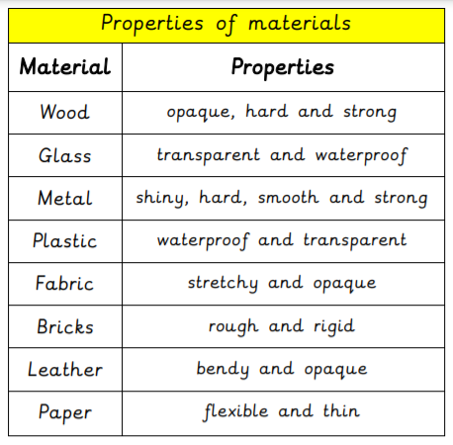

|  |  |
| --- | --- |
| **EYFS LINKS** | |
| **Communication and Language: Listening, Attention and Understanding.**   |  | | --- | | Learn new vocabulary  Use new vocabulary through the day  Ask questions to find out more and to check they understand what has been said to them.  Articulate their ideas and thoughts in well-formed sentences.  Connect one idea or action to another using a range of connectives.  Describe events in some detail  Use talk to help work out problems and organise thinking and activities explain why they might happen. | | **Expressive Arts and Design: Creating with materials.**  Safely use and explore a variety of materials, tools and techniques, experimenting with colour, design, texture, form and function.  **Understanding the World:: The Natural World**  Explore the natural world around them, making observations and drawing pictures.  Know some similarities and differences between the natural world around them.  Understand some important processes and changes in the natural world around them, including changing states of matter. |