**Homework:** W/C 14/10/2024

To be handed in: 23/10/2024

**Spellings**

Please try and practice your spellings everyday using Look, Cover, Write, Check.

|  |
| --- |
| Spellings |
|  |
|
|
|
|
|
|
|
|
|

**Reading**

Please try to read for 20 minutes each evening with an adult or independently. Please make a note of this in your Reading Record book.

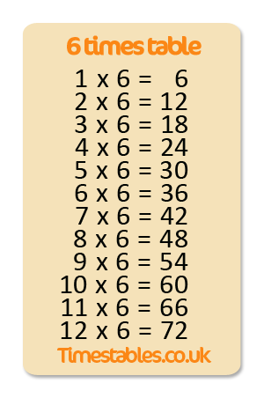**Maths**

Please try to practice your **6 x tables,** three times this week.

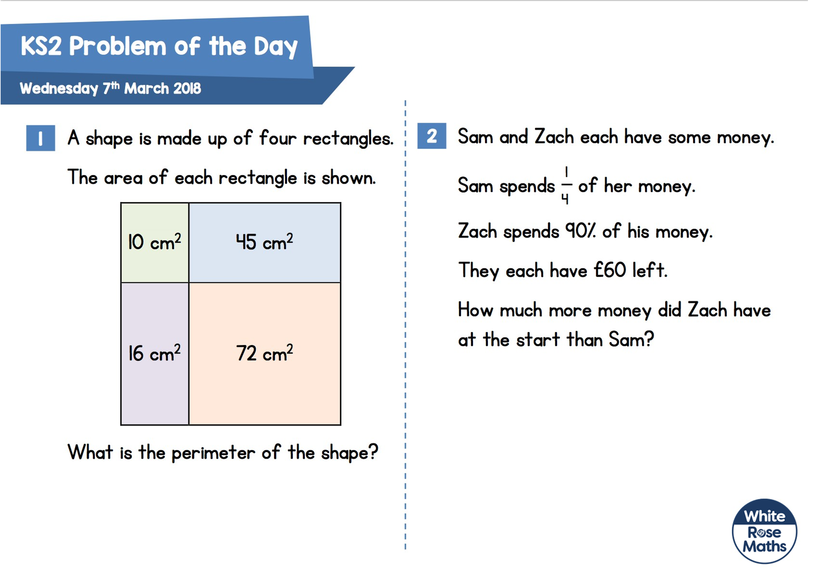

Here are some problem-solving questions for you to try too!

**English comprehension**

Please find this week’s VIPERS questions on the separate sheet of paper!