Key Vocabulary
Apes | A group of primates that includes chimpanzees, gorillas, and orangutans.
Primates | A category of mammals that includes monkeys, apes, and humans.
Planet | A large celestial body that orbits a star, like Earth.
Climate Change | Long-term changes in temperature and weather patterns on Earth.
Naturalist | A person who studies plants and animals in their natural environment.
David Attenborough | A famous British broadcaster and naturalist known for his wildlife documentaries.
Jane Goodall | A renowned British primatologist known for her work with chimpanzees.
Conservation | The protection and preservation of the natural environment and wildlife.
Extinction | When a species no longer exists anywhere on Earth.
Ecosystem | A community of living organisms and their environment interacting together.
Biodiversity | The variety of different species of plants and animals in a particular area.
Habitat | The natural home or environment of an animal, plant, or other organism.

Knowledge Outcomes:
- To identify who David Attenborough and Jane Goodall are.
- To explain what climate change and extinction mean.
- To describe the work of Jane Goodall in ape conservation.
- To discuss the contributions of David Attenborough to understanding the natural world.
- To recognise the similarities and differences between Attenborough and Goodall.
- To understand the importance of naturalists in protecting the environment.
- To describe how human actions can impact wildlife and ecosystems.
- To explain the role of conservation in preserving species and habitats.



Interesting Facts
- David Attenborough has been making nature documentaries for over 60 years!
- Jane Goodall lived in the jungle with chimpanzees for over 60 years to study their behaviour.

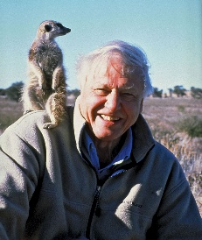
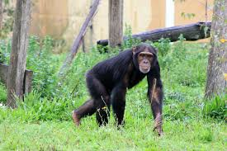
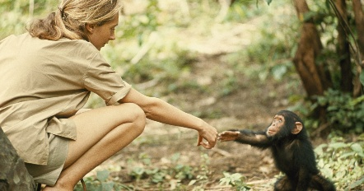

EYFS LINKS
Communication and Language: Listening, Attention and Understanding
Learn new vocabulary
Use new vocabulary through the day
Ask questions to find out more and to check they understand what has been said to them.
Articulate their ideas and thoughts in well-formed sentences.
Connect one idea or action to another using a range of connectives.
Describe events in some detail
Use talk to help work out problems and organise thinking and activities explain why they might happen.

Understanding the World: The Natural World
Explore the natural world around them, making observations.
Know some similarities and differences between the natural world around them and contrasting environments, drawing on their experiences and what has been read in class.
Understand some important processes and changes in the natural world around them, including life cycles.
Useful Websites
- BBC Earth: A website featuring documentaries and articles about wildlife and nature.
- Jane Goodall Institute: Offers information about Jane Goodall’s work and conservation efforts.
- David Attenborough’s Documentaries: Various documentaries available on platforms like Netflix, showcasing wildlife and environmental issues.
- National Geographic Kids: A resource with articles and videos about animals and nature for children.



