**ANCIENT EGYPT Knowledge Organiser – Acorns Class**

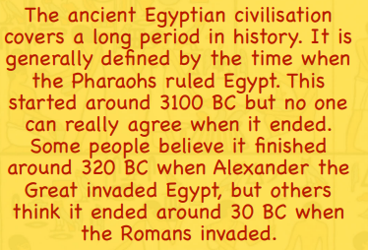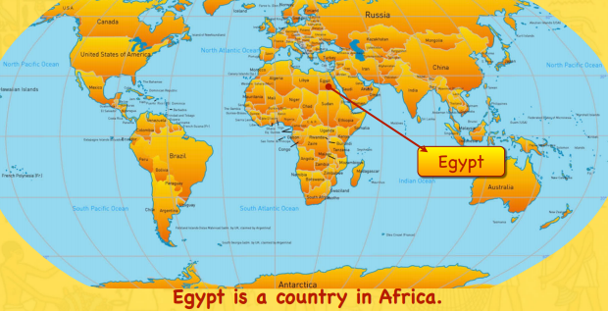

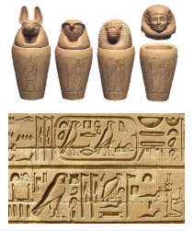

|  |  |
| --- | --- |
| **Vocabulary** | **Definition** |
| Ancient | Belonging to the very distant past and no longer in existence |
| Civilisation | The stage of human social and cultural development and organization that is considered most advanced |
| Pharaoh | A [ruler](https://www.google.com/search?safe=strict&rlz=1c1gcev_engb877gb883&q=ruler&si=AMnBZoGP34IVl-vQ5XB3AyP2dfbgEGchTqR-hVCNnS-0JKyhkz8s3x7NJElAJXCNqk9a8iNkB_D5TRQQwYGX93ItDYnOrCLA3A%3D%3D&expnd=1) in ancient Egypt |
| Sarcophagus | A stone [coffin](https://www.google.com/search?safe=strict&rlz=1c1gcev_engb877gb883&q=coffin&si=AMnBZoEP2YukYW07_nAjizsjQPEk68b8DnyBjxa399P0fPA_rfej-fnnENyYTmYMx0AUcjINIH_EO6x7K04_xT9OdoWVnx0CaA%3D%3D&expnd=1), typically [adorned](https://www.google.com/search?safe=strict&rlz=1c1gcev_engb877gb883&q=adorned&si=AMnBZoFHF1DJLZWpTBtQDK262RMpgChbrqQfLSS5QN9fbSJgAiTrGVVuw6bzMQp_iy_gg0ZrqUK9cYPGh5Eqmx3yAUIEZHoAGg%3D%3D&expnd=1) with a sculpture or inscription and associated with the ancient [civilisations](https://www.google.com/search?safe=strict&rlz=1c1gcev_engb877gb883&q=civilizations&si=AMnBZoEFBhyZNIanF2PLYT1JPeYeO0HOTKqtJnTZMIMWIgFCjTKdcMBdj1ToXH7cwvpz3aLGHE8OcRwMg0D5LzspwNY3C0EqfyBt9G4PhI1OsA7wDJUZbyo%3D&expnd=1). |
| Canopic Jar | 1. A covered urn used in ancient Egyptian [burials](https://www.google.com/search?safe=strict&rlz=1c1gcev_engb877gb883&q=burials&si=AMnBZoFHF1DJLZWpTBtQDK262RMp3zhFoKZl1b1ZkJ65ry0aAJQ6rD-RZ_1mZm7JAZ9At4qM7m6tUDBKXjmyMmyb_R9yspQHlQ%3D%3D&expnd=1) to hold the [entrails](https://www.google.com/search?safe=strict&rlz=1c1gcev_engb877gb883&q=entrails&si=AMnBZoFm76bvId4K9j6r5bU9rVYrx5ScxN5luikjvY_quk9EsiSI0mSl3jjh7vNOHmlecaPLRQWAf5sXKUuUMzjY1SYKoHIcbA%3D%3D&expnd=1) and other organs from an [embalmed](https://www.google.com/search?safe=strict&rlz=1c1gcev_engb877gb883&q=embalmed&si=AMnBZoFm76bvId4K9j6r5bU9rVYr0D-vsNnB4wuMM7cd4yvMtYQEzPVLFlSAt1WsQQhwWgKdunzin-8Kawiuh0dA1vuvzt25KA%3D%3D&expnd=1) body. |
| Hieroglyphics | A [stylised](https://www.google.com/search?safe=strict&rlz=1c1gcev_engb877gb883&q=stylized&si=AMnBZoFm76bvId4K9j6r5bU9rVYrJpMwbj_UIHE7uyNG7MrSS6znC6jemsyVSYgLM_gw370gZQVla9BJJGPRo7jBeVnHognrbA%3D%3D&expnd=1) picture of an object representing a word, [syllable](https://www.google.com/search?safe=strict&rlz=1c1gcev_engb877gb883&q=syllable&si=AMnBZoFm76bvId4K9j6r5bU9rVYreOeLojJkRUwAfcB1eXTZ0tYk7ry0s0UxjRTB1rAHXKoJTyfc3dW7Y89KRxQ4hfWUk9sd_A%3D%3D&expnd=1), or sound, as found in ancient Egyptian and certain other writing systems |
| Mummifcation | The process of preserving a dead body as a mummy |
| Shaduf | Long pole with a bucket on one end and a weight on the other, balanced on a pivot point like a seesaw. used to move water from a low place to a higher place, like from a river or well to land for watering crops. |

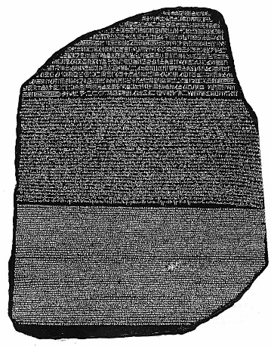

[This Photo](https://vaixelldodisseu.blogspot.com/2010/11/el-grec-i-la-pedra-rosetta.html) by Unknown Author is licensed under [CC BY-SA-NC](https://creativecommons.org/licenses/by-nc-sa/3.0/)

The Rosetta Stone

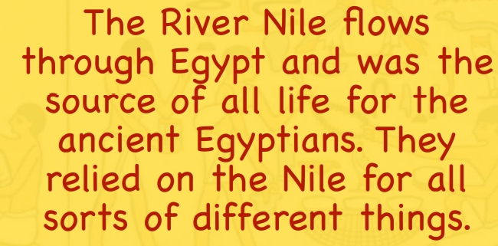 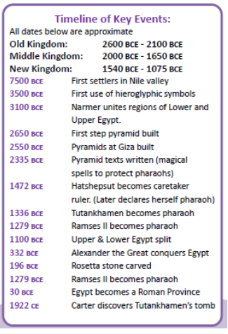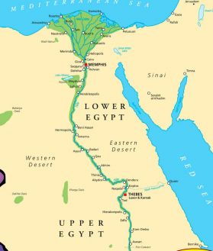

We will also be learning about the River Nile:

* What is a river?
* Name the different elements of a river?
* What is the river in Egypt called?
* What is the water cycle?

**Core Content:**

* Place Egyptian key dates in chronological order in addition to previous history taught
* Identify where Egypt is and the significance of the River Nile to the formation of the civilisation
* Recognise how we know about this period of history; to use primary and secondary sources to support their views.
* The archaeological significance of the tomb of Tutankhamun; how did this help archaeologists to better understand Ancient Egypt.
* The significance of the Rosetta Stone and how this supported archaeologists.
* The pyramids: how where they built and why? Why are there so many theories?
* Identify how we know about Egyptian life and how the Egyptians impacted on the rest of the world.
* Comparison of the Ancient Egyptians to what was happening in Britain at the same time.
* The end of the Ancient Egyptians and how this links to the Romans

