|  |  |
| --- | --- |
| **Key Vocabulary** | |
| **Habitat** | The natural home or environment where a plant or animal lives. |
| **Microhabitat** | A small and specific habitat that suits particular plants or animals, such as under a rock. |
| **Interdependence** | The way in which plants and animals rely on each other to survive. |
| **Biodiversity** | The variety of living things in a particular area. |
| **Adaptation** | A change that helps a living thing survive better in its habitat. |
| **Extremes** | Conditions that are very harsh or severe, like deserts or polar regions. |
| **Woodland** | An area covered with trees and undergrowth. |
| **Ocean Life** | The various forms of life found in the ocean, including plants and animals. |
| **Non-living** | Things that are not and have never been alive, like rocks or water. |
| **Classification** | The process of grouping living things based on shared characteristics. |

 

**Knowledge Outcomes:**

* I can identify a variety of plants and animals in a local habitat.
* I can identify animals and plants in extreme conditions and woodland habitats.
* I can explore microhabitats and identify their inhabitants.
* I can understand food sources for ocean life.
* I can discuss interdependence among living things.
* I can explore and compare living, dead, and non-living things.
* I can classify plants and animals based on different criteria.
* I can gather and record data on local habitat biodiversity.
* I can reflect on how living things adapt to their habitats and the effect on their diets.

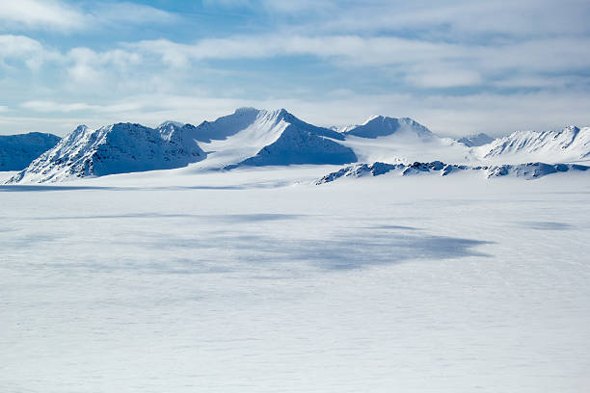

**Interesting Facts**

* A single oak tree can support over 500 different species of insects!
* There are more species of plants and animals in rainforests than in any other habitat.
* Some fish, like the clownfish, have special relationships with sea anemones - they can live among their stinging tentacles without getting hurt!

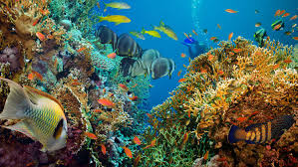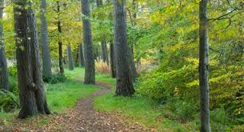

|  |
| --- |
| **EYFS LINKS** |
| **Communication and Language: Listening, Attention and Understanding**  Learn new vocabulary  Use new vocabulary through the day  Ask questions to find out more and to check they understand what has been said to them.  Articulate their ideas and thoughts in well-formed sentences.  Connect one idea or action to another using a range of connectives.  Describe events in some detail  Use talk to help work out problems and organise thinking and activities explain why they might happen.  **Understanding the World:: The Natural World**  Explore the natural world around them, making observations.  Know some similarities and differences between the natural world around them and contrasting environments, drawing on their experiences and what has been read in class.  Understand some important processes and changes in the natural world around them, including life cycles. |

**Useful Websites**

* [BBC Bitesize - Habitats](https://www.bbc.co.uk/bitesize/topics/zx882hv) - Great resource for children about habitats.
* [National Geographic Kids - Animals](https://kids.nationalgeographic.com/animals) - Information about various animals and their habitats.
* [Learning about Biodiversity](https://www.woodlandtrust.org.uk/blog/2020/08/what-is-biodiversity/) - Insight on biodiversity and why it is important.
* [Wildlife Trust](https://www.wildlifetrusts.org/) - Information on the wildlife and habitats in your local area.

