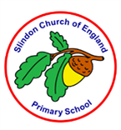

**Science Knowledge Organiser Y5/6 – Animals Including Humans**

|  |  |
| --- | --- |
| **Key vocabulary** | |
| Asexual reproduction | Offspring get genes from one parent so are clones of their parents |
| Foetus | An unborn or unhatched offspring of a mammal, in particular an unborn human more than eight weeks after conception |
| Gestation | The process or period of developing inside the womb between conception and birth |
| Offspring | A person’s child or children/ an animal’s young |
| Puberty | The period during which adolescents reach sexual maturity and become capable of reproduction |
| Reproduction | The production of offspring by a sexual or asexual process |
| Sexual reproduction | Offspring get genes from both mum and dad, inheriting a mix of features from both |
| Arteries | Muscular-walled tubes that transport blood from the heart to other parts of the body |
| Blood | Red liquid that circulates in arteries and veins, carrying oxygen to and carbon dioxide from tissues of the body |
| Blood vessel | A tubular structure carrying blood through the tissues and organs |
| Circulatory system | The system that circulates blood through the body, including the heart, blood vessels and blood |
| Heart | A hollow muscular organ that pumps the blood through the circulatory system |
| Lungs | Pair of organs situated within the ribcage where oxygen can pass into the blood and carbon dioxide be removed |
| Veins | Tubes forming part of the blood circulation system of the body, carrying mainly oxygen-depleted blood towards the heart |

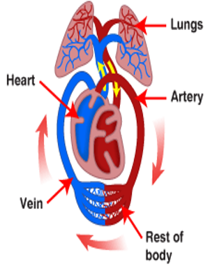

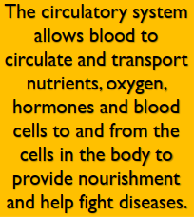

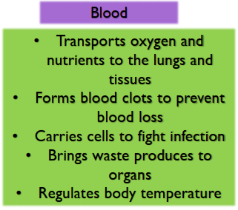

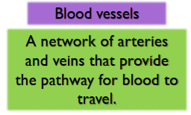

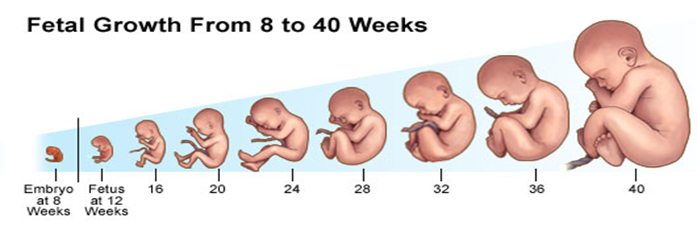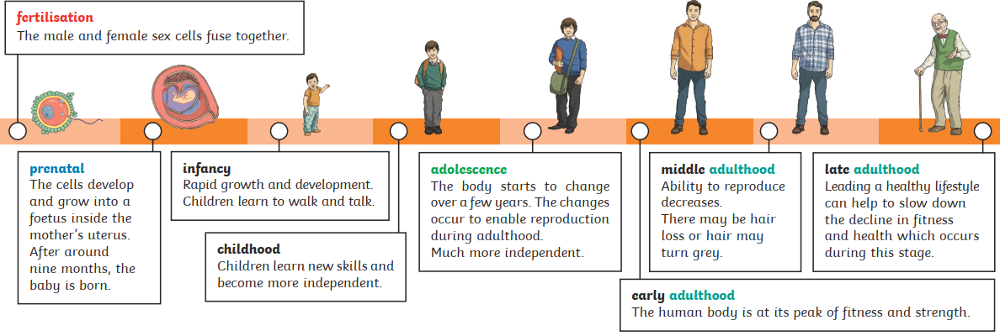

**Assessment**

* To describe the changes as humans develop to old age
* To explain how babies grow and develop
* To compare the changes that take place to boys and girls during puberty
* To understand the changes that take place in old age
* To investigate the gestation periods of different animals
* To identify and name the main parts of the human circulatory system
* To describe the functions of the heart, blood vessels and blood
* To describe the ways in which nutrients and water are transported within animals, including humans

As humans grow, they undergo many **physical** and **emotional changes**. As a **child**, we learn **new skills** such as **walking** and **talking** and as we develop into **old age**, we may get **wrinkles** and **greying hair**. These changes are all part of the **human life cycle**.

During **puberty,** boys and girls will undergo **physical changes** as they get older. They can increase in height and weight, they may get acne or spots and their **moods** **can change** regularly.

In boys, they may grow **body** **and facial hair**, their **voices** can get **deeper** and their **Adam’s apple** may start to **protrude**. They may also start to have **wet dreams**.

In girls, their **breasts** will grow, their **body fat** may **increase**, including the **widening** of their **hips** and they will start **menstruation**.