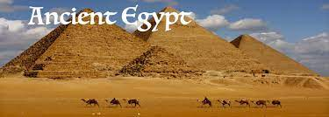
Acorns Class Summer Take Away Task 2023

This term, our focus is Ancient Egypt.
I would like you to research an aspect of Ancient Egypt and create something that demonstrates your learning.
You could research: Mummification, Canopic Jars, Egyptian Gods and Goddesses, Pyramids, The River Nile, Hieroglyphs or explore how Ancient Egyptians lived.

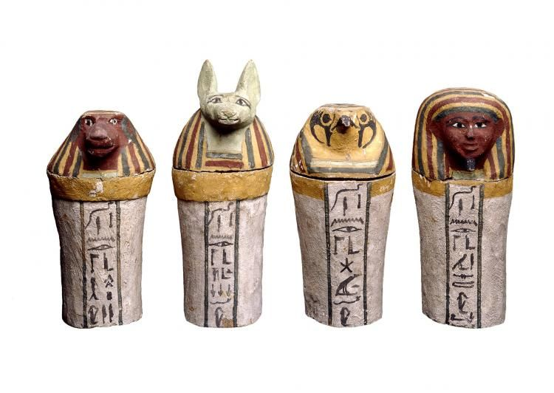
You could create:
A fact file
A poster
A power point
A piece of art

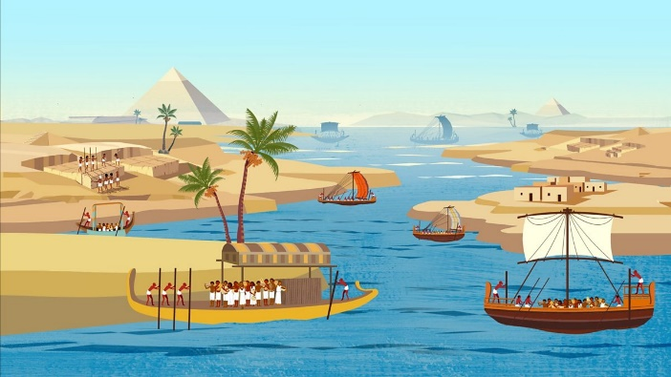
I look forward to seeing your pieces. Please return them to Miss Heater by 17th May 2023

