Key Vocabulary
abstract | Art that does not attempt to represent reality. Using shapes, colours, and texture to represent objects.
artist | A person who creates paintings or drawings as a profession or hobby.
Sculpture | The art of forming solid objects that represent a thing, person or idea.
Feminist Art | Art created by female artists since around 1970.
expressionism | A style of painting, music, or drama in which the artist or writer seeks to express the inner world of emotion.
 | Examples include; eyes, nose, mouth, ears and hair.
line | Examples: straight, curve, long short, bold, faint, sharp, thin, thick, blunt, pressure
Modern Art | Art of a style marked by a significant departure from traditional styles and values, in particular that created between the late 19th and the late 20th centuries
Environment Art | Art that relates to the natural and urban environment.
Installation Art | Three- dimensional Artwork that takes up a whole room, gallery that you can walk through.
profile | A representation of something in outline especially : a human head or face represented or seen in a side view
realistic | To represent things in a way that is accurate and true to life.
Performance Art | Live artwork that is performed by actions or a series of actions.
Post Impression | A French art movement that developed 1886.
Assessment
- I can draw a landscape inspired by Vincent van Gogh.
- I can explain what a sculpture is and compare Yayoi Kusama’s to mine.
- I can use colour to portray seasons in my artwork.
- I can talk about Vincent van Gogh artwork.
- I can talk about sculptures by Yayoi Kusama.
- I can explore line, shape and form in my work.
- I can talk about portraits by the Pop Art artist, Andy Warhol.
- I can create a pop art portrait.

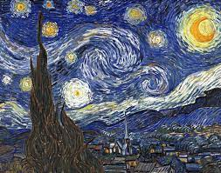

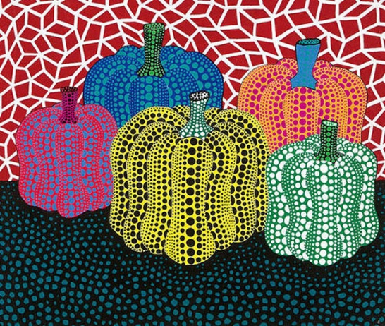

Vincent van Gogh  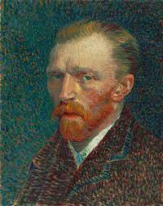 | Yayoi Kusama  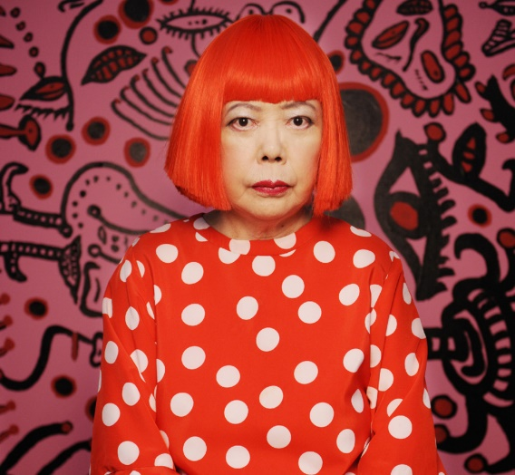
Born: 30 March 1853  Died: 29 July 1890  Style/Period: Dutch Artist Painting, drawing still life, portraits and landscapes.  Famous Works: Post Impression The Starry Night (1889), Sunflowers (1887) | Born: 22 March 1929  Style/Period: Japanese Artist Painting, Sculptures, Installation Art, Performance Art  Famous Works: Environment Art (Pumpkin) and Feminist Art (Forever Love)
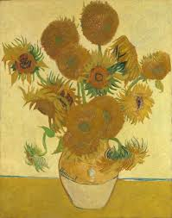  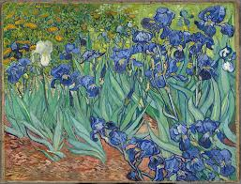 | 