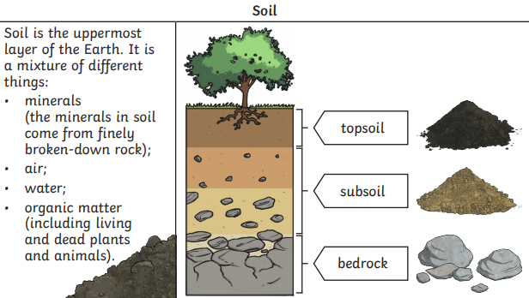If you dig down anywhere on Earth you will find rock. Rocks can be hard, soft, permeable or impermeable, depending on what type of rock it is. Slate, marble, chalk and granite are all different types of rock and all have different uses.

Core Knowledge

• Compare and group together different kinds of rocks on the basis of their appearance and simple physical properties

• Describe in simple terms how fossils are formed when things that have lived are trapped within rock

• Recognise that soils are made from rocks and organic matter.

Assessment

Enquiry question: How can rocks be identified and grouped based on their properties?

How are fossils formed?

How has human activity caused soil loss and what is the impact on living things?

Which soil absorbs the most water?

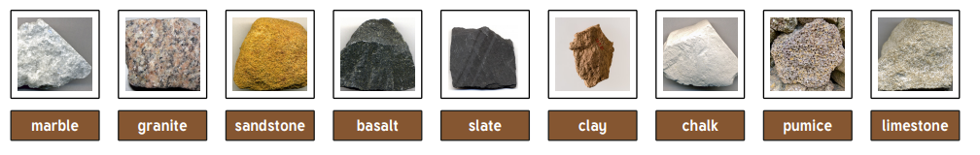

|  |  |
| --- | --- |
| **Key Vocabulary** | |
| **Texture** |  |
| **Decay** | To rot or decompose. |
| **Fossil** | The preserved remains of a dead organism. |
| **Geologist** | A person who studies rocks. |
| **Igneous Rock** | Rock formed from cooled magma. |
| **Impermeable** | Doesn't allow liquid to pass through. |
| **fossilisation** |  |
| **Organic matter** | Matter that has come from a recently living organism |
| **Metamorphic rock** | Rock formed from changes of heat or pressure. |
| **deforestation** | The clearing, or cutting down, of forests. |
| **Mine** | To dig into the Earth for rocks and minerals. |
| **Permeable** | Allows liquid to pass through. |
| **Rock** | Any naturally occurring solid mineral material. |
| **Sedimentary rock** | Rock formed by layers of sediment |
| **Soil** | Made up of pieces of rock, minerals, decaying plant material, microbes and water. |
| **Weathering** | A natural process that slowly breaks apart or changes rock. |
| **Habitat loss** | the destruction or alteration of the necessary conditions for plants and animals to survive in a particular place. |

