|  |  |
| --- | --- |
| **Key Vocabulary** | |
| **Absorbent** | Able to soak up liquid easily |
| **Conductor** | A material or device which allows heat or electricity to carry through |
| **Dissolve** | When something solid mixes with a liquid and becomes part of the liquid |
| **Evaporation** | The process of turning from liquid to vapour |
| **Filtering** | When a solid is removed from a liquid |
| **Gas** | An air-like fluid substance which expands freely to fill any space available |
| **Insoluble** | Does not dissolve in a liquid |
| **Insulator** | A substance which does not readily allow the passage of heat or sound |
| **Irreversible** | Cannot be reversed back to its original state |
| **Liquid** | A substance that flows freely but can be measured by volume e.g. water or oil |
| **Material** | The matter from which a thing is or can be made from |
| **Opaque** | Not able to be seen through, not transparent |
| **Reversible** | Able to be reversed back to its original state |
| **Sieving** | The process of seperating solids or a solid from a liquid |
| **Solid** | Firm and stable in shape, not a liquid or fluid |
| **Soluble** | Able to be dissolved, especially in water |
| **Solute** | Something that is dissolved in liquid |
| **Solution** | A mixture where a solid has dissolved into a liquid |
| **Solvent** | A liquid in which a solute is dissolved |
| **Thermal** | Relating to heat |
| **Transparent** | Allows light to pass through so that objects behind can be seen |

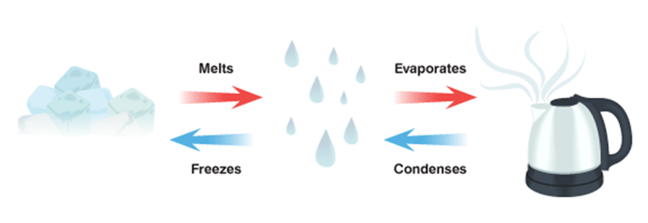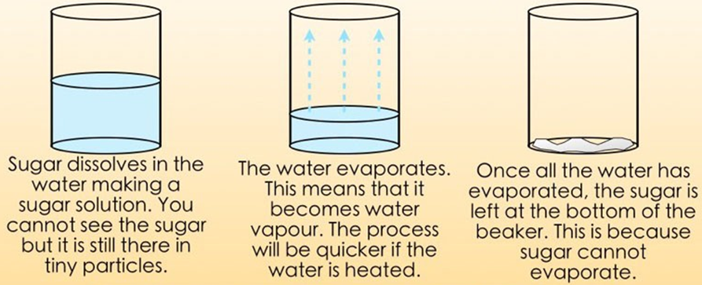 

Materials can be **solids**, **liquids** or **gases**. In some solids the bonds between particles break when surrounded by a liquid; this allows the liquid to absorb the solid; when this happens, the solid is called a **solute**, the liquid is called a **solvent** and the result is a **solution**; when a solid does **dissolve** in a liquid it is described as being **soluble** in that solvent (e.g. sugar in water); when it cannot it is **insoluble** (e.g. sand in water).

When sugar is mixed with water, it forms a **solution**. The sugar seems to disappear in the water. If the solution is boiled, the solid can be recovered. The water will **evaporate** into a **gas** and the solid will be left behind.

Some changes are **reversible** (can be changed back) whilst  
 others are **irreversible** (cannot be reversed)

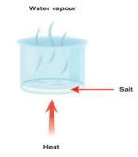****

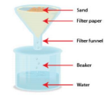

An insoluble solid can be separated from a liquid when  
passed through a **filter**. The liquid can pass through the  
filter whilst the solid particles are trapped in the filter.

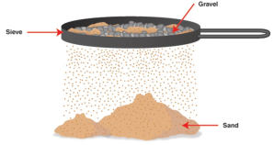

By **dissolving** salt in water we make a **solution**. The salt dissolves (seems to disappear) into the water. We can separate the salt from the water by boiling a solution. The water will **evaporate** until it is all gone. The salt will be left behind.

A mixture of different solid particles can be separated  
using a **sieve.**

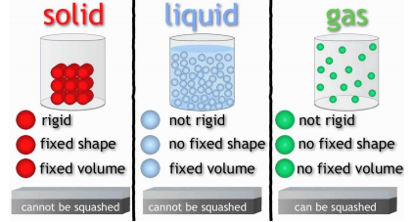

**Assessment**

* To group every day materials according to their properties
* To plan an absorbency enquiry
* To carry out and evaluate an absorbency enquiry
* To revise the three states of matter
* To investigate solubility of materials
* To suggest how mixtures can be separated
* To carry out a solutions enquiry (dissolving or retrieving substances)
* To investigate thermal conductivity
* To separate materials using sieves
* To understand changes that are irreversible and why
* To discuss how new materials are formed