|  |  |
| --- | --- |
| **Key Vocabulary**  **Knowledge Outcomes**   * I can identify and name a variety of animals, including fish, reptiles, amphibians, birds, and mammals. * I can describe the basic needs of humans and animals, including what they need to survive (water, food, air). * I can explain the difference between healthy and unhealthy diets, including examples of foods from both categories. * I can understand the importance of exercise and hygiene for maintaining physical and mental health. * I can recognise that all animals, including humans, go through life cycles and have offspring. * I can ask questions about animals and gather information to help answer these questions scientifically. | |
| **Shelter** | A place where an animal or human lives, providing protection from the weather and danger. |
| **Heart** | The organ in the human body that pumps blood and keeps us alive. |
| **Exercise** | Physical activity that helps strengthen our bodies and keep us healthy. |
| **Physical Health** | The state of being free from illness or injury; how well our body functions. |
| **Mental Health** | The state of our emotional and psychological well-being; how we think and feel. |
| **Healthy Diet** | Eating a variety of foods that help our bodies grow and stay strong. |
| **Unhealthy Diet** | Eating too many foods that are high in sugar, salt, or fat which can be bad for our bodies. |
| **Meat** | The flesh of animals used as food, such as chicken, beef, or fish. |
| **Sugar** | A sweet substance found in some foods that can be unhealthy if eaten too much. |
| **Germs** | Tiny organisms that can cause diseases; they are too small to see. |
| **Hygiene** | Keeping our bodies clean to stay healthy and avoid germs. |
| **Doctor** | A trained professional who helps people stay healthy and treat illnesses. |
| **Disease** | An illness or health condition that affects the body. |
| **Plaque** | A sticky layer of bacteria that forms on the teeth. |
| **Gums** | The soft tissue in the mouth that surrounds the teeth. |
| **Filling** | A material used to repair a tooth that has a cavity. |
| **Offspring** | The young born to an animal or human. |
| **Egg** | The reproductive structure from which many animals, including birds, hatch their offspring. |
| **Parent** | A mother or father. |
| **Baby** | A very young human. |
| **Child** | A young human who is not yet a teenager; someone between baby and teenager. |
| **Teenager** | A young person aged between 13 and 19 years old. |
| **Life Cycle** | The stages a living organism goes through from birth to adulthood. |
| **Adolescent** | A young person in the process of developing from a child into an adult. |
| **Tadpole** | The young stage of a frog that lives in water and has a tail. |
| **Frogspawn** | The eggs of a frog that hatch into tadpoles. |
| **Froglet** | A young frog that has developed from a tadpole. |
| **Caterpillar** | The larval stage of a butterfly or moth. |
| **Pupa** | The stage in the life cycle of an insect when it is developing into an adult. |
| **Butterfly** | A flying insect with colourful wings that develops from a caterpillar. |
| **Insect** | A small creature with six legs and three body parts. |
| **Adult** | A fully developed human or animal. |

 

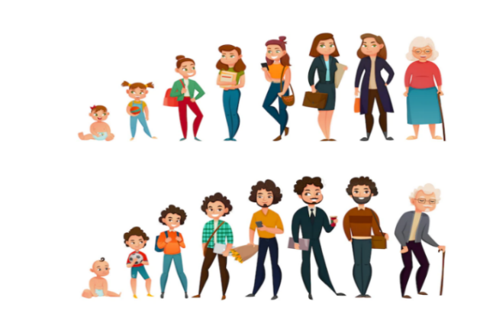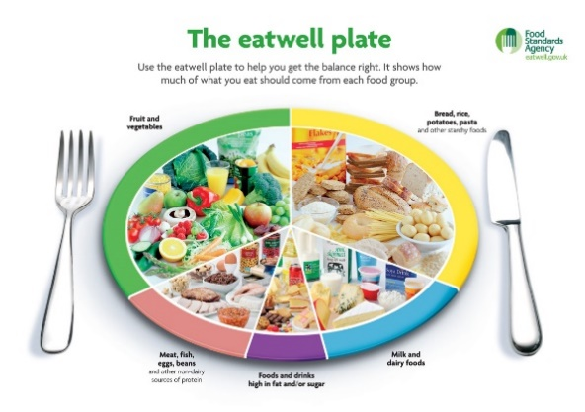

**Interesting Facts:**

A frog can lay thousands of eggs at once, but only a few grow into adult frogs!

Cats have around 32 muscles in each ear, allowing them to rotate their ears independently!





