Key Vocabulary
Continent | A large landmass on Earth; we have 7 continents: Asia, Africa, North America, South America, Antarctica, Europe, and Australia.
Ocean | A vast body of saltwater that covers much of the Earth's surface; there are 5 oceans: Pacific, Atlantic, Indian, Southern, and Arctic Ocean.
Sea | A large body of saltwater smaller than an ocean, often partially enclosed by land.
Capital City | The city where the government of a country is located.
Country | A nation with its own government, occupying a particular territory.
Equator | An imaginary line around the middle of the Earth that divides it into the Northern Hemisphere and the Southern Hemisphere.
North Pole | The northernmost point on Earth, located at the top of the globe.
South Pole | The southernmost point on Earth, located at the bottom of the globe.
Temperature | A measure of how hot or cold something is.
Climate | The average measure of temperature, wind, humidity, snow and rain in a place over a long time.
Weather Conditions | The way the air and atmosphere feels with different types of weather.
Arctic | The area around the North Pole; very cold.
Desert | A very dry place that gets very little rain, where only some plants and animals can live.
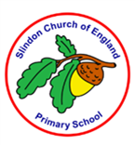
Knowledge Outcomes:
- I can name and locate the seven continents on a world map.
- I can locate the North and the South Poles on a world map.
- I can locate the equator on a world map.
- I can describe some similarities and differences between the UK and Antarctic.
- I can recognise the features of a hot and cold country.
- I can explain the weather patterns and climates of different places around the world.
- I can locate some countries with hot or cold climates on a world map.


Useful Websites:
- National Geographic Kids: A great resource for educational videos and articles about geography and explorers.
- BBC Bitesize - Geography: Interactive learning resources and activities for geography.
- Google Earth: Explore the world from your classroom with interactive maps and tools.


Interesting facts:
- The hottest places on Earth are often deserts, where it can be so hot that sand feels too hot to walk on barefoot.

- Some cold places stay frozen all year round, and the ground can be permanently frozen - this is called permafrost.

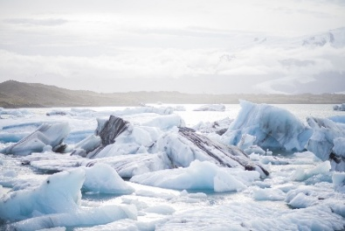
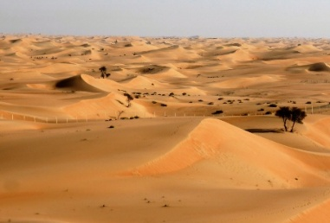

EYFS LINKS
Communication and Language: Listening, Attention and Understanding.
Learn new vocabulary
Use new vocabulary through the day
Ask questions to find out more and to check they understand what has been said to them.
Articulate their ideas and thoughts in well-formed sentences.
Connect one idea or action to another using a range of connectives.
Describe events in some detail
Use talk to help work out problems and organise thinking and activities explain why they might happen.

Understanding the World: Past and Present
Talk about the lives of the people around them and their roles in society.
Know some similarities and differences between things in the past and now, drawing on their experiences and what has been read in class.
Understand the past through settings, characters and events encountered in books read in class and storytelling.
