|  |  |
| --- | --- |
| Key Vocabulary | |
| **Aeroplane** | A powered flying vehicle with wings that can carry people or goods over long distances. |
| **Air Transport** | Vehicles that travel in the sky, like planes and helicopters. |
| **Era** | A period of time marked by distinctive characteristics. |
| **Horse-drawn Carriage** | A carriage that is pulled by horses, common before the invention of cars. |
| **Land Transport** | Vehicles that travel on roads, such as cars and buses. |
| **Past** | Referring to a time that has already happened. |
| **Present** | Referring to the current time or now. |
| **Steam Engine** | A machine that uses steam to power trains and boats. |
| **Steam Train** | A type of train powered by steam engines, used in the 19th and early 20th centuries. |
| **Technology** | Tools or machines that help us do work or communicate. |
| **Timeline** | A visual representation showing the order of events in history. |
| **Transport** | A way of getting from one place to another, like cars, trains, or bicycles. |
| **Water Transport** | Vehicles that travel on water, such as ships and boats. |

 

**Knowledge Outcomes:**

* I can explore different forms of transport and the concept of timelines.
* I can match forms of transport to different ages or time periods.
* I can explain why transport changed over time.
* I can make links to changes in living memory and beyond.
* I can describe different types of transport and their uses.
* I can create an advert for modes of transport from the past and present.

**Interesting fact!**

The first bicycles were made of wood!

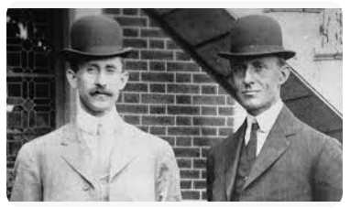

**EYFS LINKS**

**Communication and Language: Listening, Attention and Understanding.**

|  |
| --- |
| Learn new vocabulary  Use new vocabulary through the day  Ask questions to find out more and to check they understand what has been said to them.  Articulate their ideas and thoughts in well-formed sentences.  Connect one idea or action to another using a range of connectives.  Describe events in some detail  Use talk to help work out problems and organise thinking and activities explain why they might happen.  **Understanding the World: Past and Present**  Talk about the lives of the people around them and their roles in society.  Know some similarities and differences between things in the past and now, drawing on their experiences and what has been read in class.  Understand the past through settings, characters and events encountered in books read in class and storytelling. |

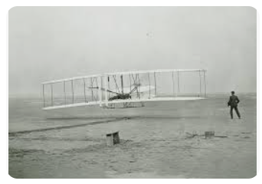

**The Wright Brother’s**

**First Flight**

