|  |  |
| --- | --- |
| **Key Vocabulary** | |
| **Castle** | A large fortified building, often with thick walls and towers. |
| **Knight** | A man who served as a mounted soldier in the Middle Ages, often given the title of 'Sir.' |
| **Moat** | A deep, wide ditch surrounding a castle, typically filled with water to prevent attacks. |
| **Drawbridge** | A bridge that can be raised or lowered to allow entrance to a castle over the moat. |
| **Keep** | The strongest part of a castle, often used as a living space for the lord and his family. |
| **Battlements** | Low walls built on the top of a castle wall, allowing defenders to attack from a height. |
| **Turrets** | A small tower, often found at a corner of a castle. |
| **Portcullis** | A heavy grilled door that can be dropped down to keep out attackers. |
| **Artefact** | An object made by a human being, often of historical or cultural interest. |
| **Siege** | A military operation where forces surround a castle to force surrender. |
| **Nobility** | The social class that holds high status, often owning land and ruling in a kingdom. |
| **History** | The study of past events, particularly in human affairs. |
| **Evidence** | Information or details that help prove something or tell us about the past. |
| **Local History** | The history of a specific area or community. |

 

**Knowledge Outcomes:**

I can explore castles and find out why they were built.

I can investigate the design and features of a typical castle.

I can understand who lived in castles and their various roles.

I can analyse primary and secondary sources related to castles.

I can use evidence to recreate the story of a castle.

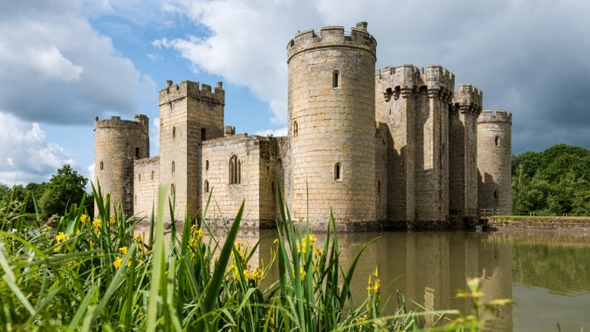

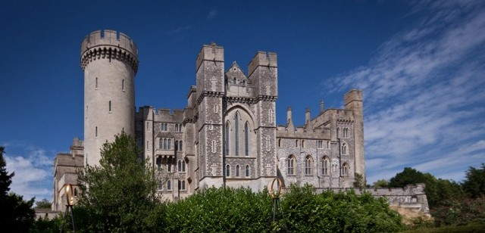

**Bodiam Castle**

**Arundel Castle**

**Timeline of events:**

**EYFS LINKS**

**Communication and Language: Listening, Attention and Understanding.**

|  |
| --- |
| Learn new vocabulary.  Use new vocabulary through the day.  Ask questions to find out more and to check they understand what has been said to them.  Articulate their ideas and thoughts in well-formed sentences.  Connect one idea or action to another using a range of connectives.  Describe events in some detail.  Use talk to help work out problems and organise thinking and activities explain why they might happen.  **Understanding the World: Castles**  Explore the natural world around them, making observations.  Observe different castles built in different environments.  Know some similarities and differences between the natural world around them and contrasting environments, drawing on their experiences and what has been read in class.  Develop an understanding of the different physical features around them such as hill, river, and cliff. |

**Interesting facts:**

Arundel Castle was once the home of the Duke of Norfolk and is still used for nobility today.

**Useful and Reliable Websites:**

* [English Heritage - Castles](https://www.english-heritage.org.uk/visit/places/)
* [Historic England - Castles](https://historicengland.org.uk/advice/technical-advice/buildings/castles/)
* [BBC Bitesize - Castles](https://www.bbc.co.uk/bitesize/topics/zq2kqp3)
* [National Trust - Bodiam Castle](https://www.nationaltrust.org.uk/bodiam-castle)
* [Arundel Castle Official Site](https://www.arundelcastle.org/)