|  |  |
| --- | --- |
| Vocabulary | Definition |
| Reflect | Throw back (heat, light, or sound) without [absorbing](https://www.google.com/search?safe=strict&rlz=1c1gcev_engb877gb883&q=absorbing&si=AMnBZoFEI0LGJdD1jElhAGFwRnmoT3vCfJhYwKzl2sLM8SszY5Uxwxl4JzGaqZab8fetvVJ2sWPhpk3oBVJ2C1qzx1XP0DkMcQ%3D%3D&expnd=1) it |
| Light | The natural agent that [stimulates](https://www.google.com/search?safe=strict&rlz=1c1gcev_engb877gb883&q=stimulates&si=AMnBZoFY6cJe4EcBOpcoqxHCe-IfqaeH0-vVnI0jGT2cIk5BzSw6MfZ6nlJInqEDra5FmeXxDjFLRff_LUxw1f0LY97jT687lw%3D%3D&expnd=1) sight and makes things visible |
| Shadows | Dark area or shape produced by a body coming between rays of light and a surface. |
| Opaque | Not able to be seen through; not transparent |
| Transparent | Allowing light to pass through so that objects behind can be [distinctly](https://www.google.com/search?safe=strict&rlz=1c1gcev_engb877gb883&q=distinctly&si=AMnBZoFY6cJe4EcBOpcoqxHCe-IfffyWdwDUY9orWz2tce46oQkIrE7BIcJjo01cLayUGUDP6FW7aEDEqWW1C98iprTJwpCYBQ%3D%3D&expnd=1) seen |
| Translucent | Allowing light, but not detailed shapes, to pass through; semi-transparent. |
| Dark | With little or no light |

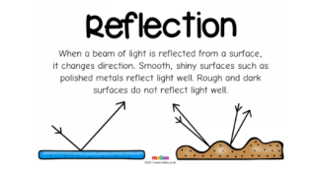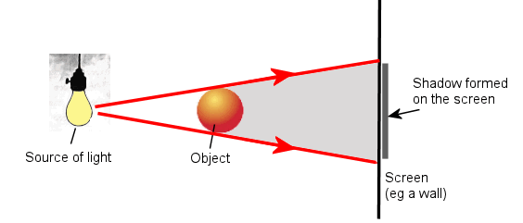

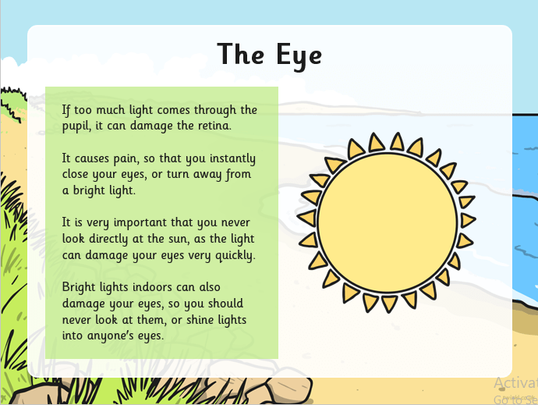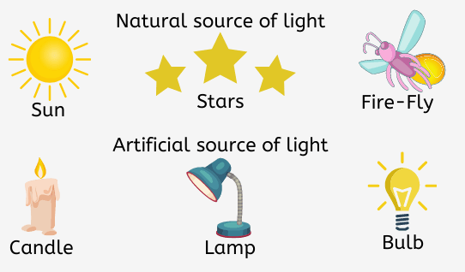

**The children will work scientifically by:**

* Identifying differences, similarities or changes related to simple scientific ideas and processes.
* Recording findings using simple scientific language, drawings, labelled diagrams, keys, bar charts and tables.
* Gathering, recording, classifying and presenting data in a variety of ways to help in answering questions.
* Asking relevant questions and using different types of scientific enquiries to answer them.
* Setting up simple practical enquiries, comparative and fair tests.
* Using results to draw simple conclusions, make predictions for new values, suggest improvements and raise further questions.

**The children will earn to:**

* Recognise that they need light to see things and that dark is the absence of light.
* Notice that light is reflected from surfaces.
* Recognise that light from the sun can be dangerous and that there are ways to protect their eyes.
* Recognise that shadows are formed when the light from a light source is blocked by a solid object.
* Find patterns in the way that the sizes of shadows change.