Slindon Church of England Primary School

Handwriting Policy

Approved by: | Headteacher (Laura Webb)
Date: | September 2026
Last reviewed on: | September 2026
Next review due by: | September 2027

Vision

At Slindon CofE Primary school we serve our local community and enable our school family to flourish. We recognise that everyone is Unique and want to ensure they are able to Learn and Develop in a high-quality learning environment. We enrich the spirit in an Enabling Environment, in which Positive relationships foster creativity and curiosity. In hope we encourage our community to shine brightly and be courageous advocates of our world, shaping their futures for the better.
The Fruit of the Spirit is love, joy, peace, patience, kindness, goodness, faithfulness, gentleness, and self-control; against such things there is no law.
Galatians 5; 22-23
Let Your Light Shine ~ Matthew 5:16
This policy has been developed with reference to:
- the current Statutory Framework for the Early Years Foundation Stage;
- the National Curriculum in England: English Programmes of Study;
- the Department for Education’s Writing Framework; and
- the school’s Phonics and Early Reading, English and SEND policies.
These documents inform the school’s approach to the explicit, systematic and cumulative teaching of handwriting from Reception to Year 6.

Intent of our handwriting curriculum

At Slindon Church of England Primary School, we recognise that writing is integral to all aspects of life, and we endeavour to ensure that children develop a lifelong, enthusiastic attitude towards writing and recognise the Unique Child. The skill of writing enables pupils to communicate with themselves and others while documenting and conveying their knowledge and ideas, while enabling them to Learn and Develop. Building on experiences, it encourages expression and higher order thinking skills to develop. Thus, creating a culture of writing in our school ensures our children are given the best opportunities to build their capacity and confidence in a range of writing styles, developing a Positive Relationship with writing. By creating an Enabling Environment and employing appropriate resources, we are determined to provide all pupils with a supportive writing curriculum which will allow learners to recognise their full potential and develop.

We aim to teach children to write using a fluent, efficient and legible style of handwriting.
- Children should use an appropriate pencil/pen grip for their stage of development.
- Children should understand the purpose of handwriting and adapt their writing for different audiences/purposes.

- Children will, in time, develop automaticity in writing so that they can focus on the composition of their work.

Handwriting in the classroom:
The skill of handwriting needs to be taught. It is not a natural skill that will grow and develop like speaking or walking.
Pupils should eventually develop the ability to produce letters without thinking. An automatic style releases the brain to concentrate on other ideas i.e. spelling, grammar, syntax, style and content.
Effective handwriting teaching includes clear modelling, guided practice, repetition, feedback and careful observation. Teachers must demonstrate letter formation and joins regularly and children must practise by carefully copying and repeating. It is important to observe children writing to ensure they are forming letters correctly.

Handwriting principles:
Handwriting should be taught explicitly, in short, frequent sessions. It should be modelled by the teacher, then supervised. High expectations of handwriting are needed.
Teachers need to model good handwriting at all times, e.g. when writing on the whiteboard and when marking books.
The following is a brief outline of our agreed policy:
- Gross and fine motor skills: activities to develop gross and fine motor skills are essential to the development of good handwriting.

- Posture: children should be taught the importance of sitting upright and correctly on their chair, with their feet on the floor.
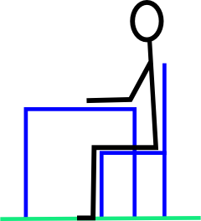
- Pencil grip: children are explicitly taught how to hold a pencil comfortably and efficiently. For most pupils, a dynamic tripod grip provides the control needed for fluent handwriting. Staff recognise that children develop physically at different rates and that some pupils may require additional practice, adapted equipment or an alternative functional grip. Gross and fine motor activities support children’s strength, coordination and control but do not replace explicit handwriting instruction. Staff monitor whether a child’s grip causes discomfort, fatigue, restricted movement or reduced fluency and seek advice from the SENCO or relevant professionals where necessary.

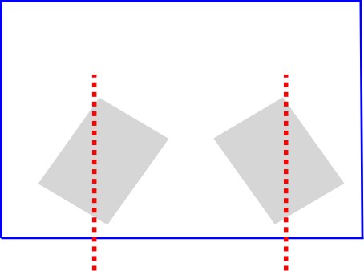
- Position of paper: left handed children should be encouraged to tilt their paper slightly to improve their view of what they are writing, and to reduce smudging later on when they write in ink. Right handed children may find it helpful to tilt paper slightly to the left. Paper should be steadied with the free hand.

- Paper: Children may use unlined paper for drawing and exploratory mark-making. During explicit handwriting teaching, pupils use appropriately sized lined paper or handwriting guides to support letter placement, relative size, ascenders and descenders. Wide-lined paper is used initially, with narrower lines introduced once pupils can write legibly and comfortably. Resources may be adapted according to individual need. Lines at an interval of 15mm will be standard in KS1, and 8mm or 10mm in KS2, although some children may have different needs.

- Pre handwriting patterns: Throughout the teaching of handwriting, children will practice the pre handwriting patterns in order to develop the strength and coordination needed to form letters as well as the flow and fluidity needed to join letters.

- Correct letter formation: children are taught to form letters correctly, paying attention to the starting point for each letter, the direction of pencil movement, the shape and orientation of the letter, and the relative heights of the body of each letter, and any ascender and descender. Teaching will be multi-sensory and appropriate to the needs of the child. Our policy is to teach a letter shape which closely resembles print for early readers, and which will not need to be changed as handwriting becomes joined. The “pattern” used in Reception to accompany correct letter formation is included in the Appendix.

- Writing implements: Pupils use a writing implement that is appropriately sized and enables a comfortable, efficient grip. Pencil and paper are generally used during early teaching and practice of handwriting. As pupils develop sufficient control and fluency, they may begin to use a school handwriting pen. In Key Stage 2, pupils are taught to select the writing implement most appropriate for the task and their individual needs.

- Challenges with handwriting: Where a pupil experiences difficulty with handwriting, staff identify the specific barriers affecting their progress. These may relate to letter formation, posture, pencil grip, physical development, visual processing, motor coordination, pain, fatigue or working memory. Teaching is adapted through smaller steps, additional modelling and practice, appropriate resources and reasonable adjustments. The class teacher works with the SENCO and, where appropriate, relevant specialists. Alternative methods of recording may be provided where necessary, while pupils continue to receive appropriate handwriting instruction.

Programme of study for Handwriting

Slindon Church of England Primary School follows the progression set out in the National Curriculum and the Department for Education’s Writing Framework. Explicit handwriting teaching begins in Reception, where children learn to form unjoined lower-case and capital letters correctly, starting and finishing each letter in the correct place. Reception and Year 1 focus primarily on secure letter formation, orientation, size and spacing. In Year 2, pupils begin to learn appropriate diagonal and horizontal joining strokes once they can form unjoined letters correctly and consistently. Fluency, legibility, consistency and speed are then developed throughout Key Stage 2.

Year 1 Pupils should be taught to:

- sit correctly at a table, holding a pencil comfortably and correctly
- begin to form lower-case letters in the correct direction, starting and finishing in the right place
- form capital letters
- form digits 0-9
- understand which letters belong to which handwriting ‘families’ (ie letters that are formed in
similar ways) and to practise these

Year 2 Pupils should be taught to:

- form lower-case letters of the correct size relative to one another
- start using some of the diagonal and horizontal strokes needed to join letters and understand which letters, when adjacent to one another, are best left un-joined
- write capital letters and digits of the correct size, orientation and relationship to one another and to lower-case letters
- use spacing between words that reflects the size of the letters

Year 3 – 4 Pupils should be taught to:
- use the diagonal and horizontal strokes that are needed to join letters and understand which letters, when adjacent to one another, are best left un-joined
- increase the legibility, consistency and quality of their handwriting, [for example, by ensuring that the down-strokes of letters are parallel and equidistant, and that lines of writing are spaced sufficiently so that the ascenders and descenders of letters do not touch]

Year 5-6 pupils should be taught to:

- write legibly, fluently and with increasing speed by:
  - choosing which shape of a letter to use when given choices and deciding whether or not to join specific letters
  - choosing the writing implement that is best suited for a task

Appendix Developmental Stages of Pencil Grips

Stage 1 of Pencil Grip Development
When your child first picks up a crayon they will hold it in the same way as they pick up a knife and fork, other than the crayon tip will be facing downwards.
Through the initial mark making process it is normal for their arm and elbow to stay rigid, with the crayon movement coming from the shoulder.

Stage 2 of Pencil Grip Development
With improved arm and hand control your child will start to hold the crayon in the palm of their hand, with their thumb securing it in their hand. Note that the thumb is now close to the tip and not the end of the crayon. The grasp is similar to that of using a knife and fork to cut food.
The increased arm strength allows the elbow to be slightly away from the body, providing greater flexibility.

Stage 3 of Pencil Grip Development
Your child will hold the pencil with all five fingers resulting in the wrist being off the table. The grip is similar to a darts player holding the dart with all five fingers.
Movement of the crayon now comes from the wrist but as the hand strength improves there will start to be some finger movement.

Stage 4 of Pencil Grip Development
Your child will usually start to use the three finger, or tripod grip, by the age of 6.
Initially the fingers will be held rigidly but, as your child improves their control of the finger muscles, the fingers will start to move the pencil.

Note:

If a toddler is taught how to hold a pencil using the tripod grip before they are physically ready, they are inclined to develop a poor pencil grip which is difficult to change once they are older. These grips can make handwriting difficult and less fluid as well as making writing a very tiring task. It can also turn some children off colouring, drawing and handwriting as they are not pleasurable experiences.

A child may not develop a three finger tripod pencil grip until the age of 5/6. This is considered the most appropriate pencil grip, for right and left handed writers, as it allows the fingers and wrist to work together to provide a more free flowing movement.

Letter formation for left-handed children
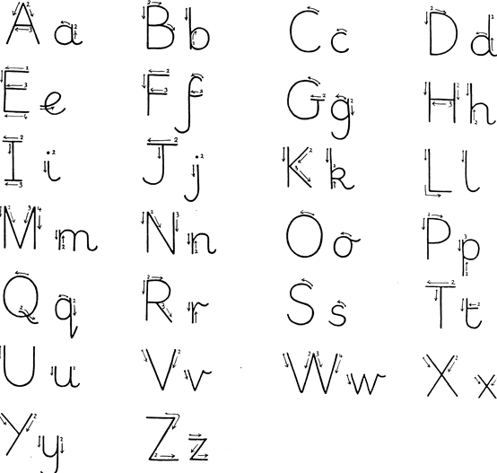

Letter formation for right-handed children

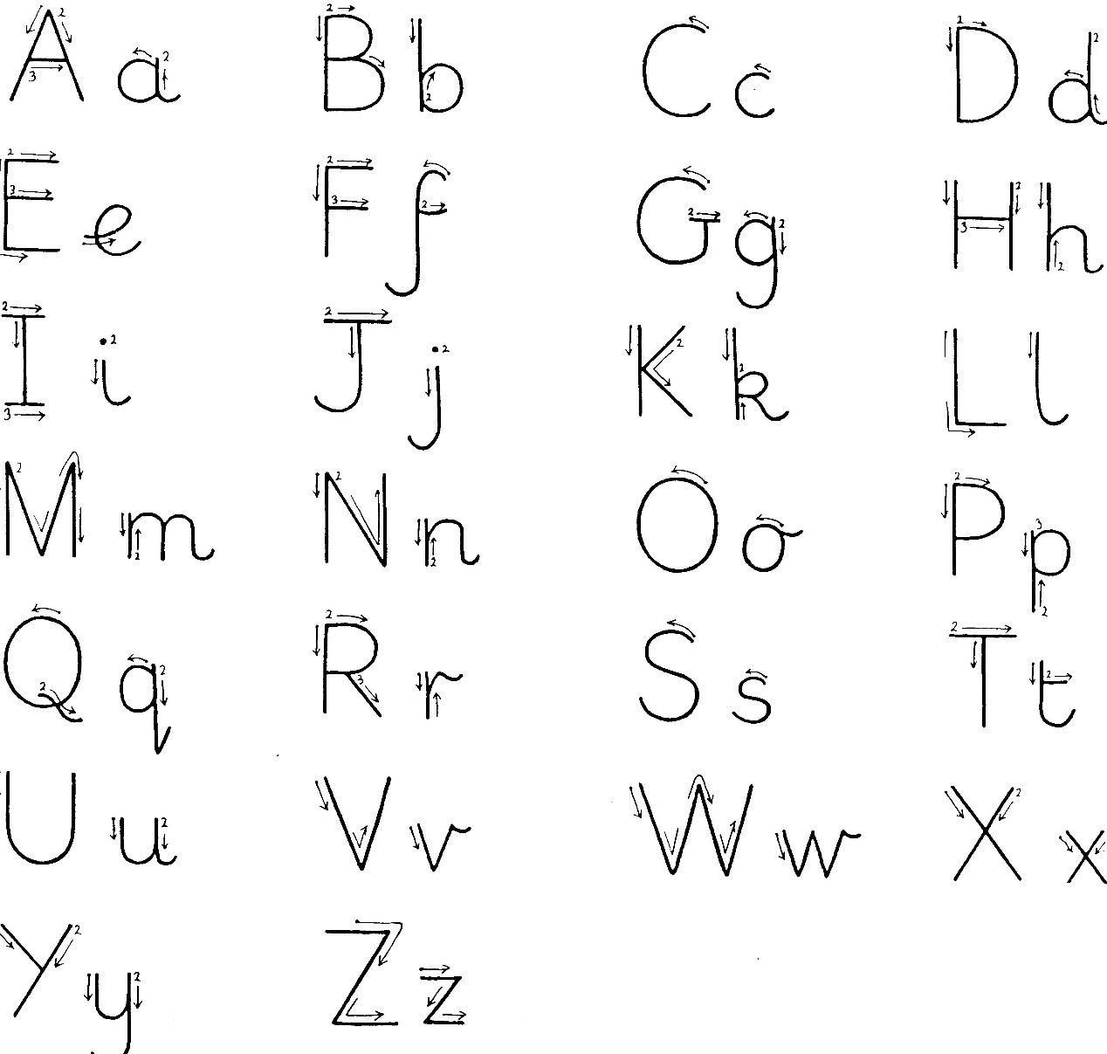

Letter formation families

