|  |  |
| --- | --- |
| Key Vocabulary | |
| Air resistance | A type of friction caused by air pushing against any moving object |
| Force | A push or pull upon an object resulting from its interaction with another object |
| Friction | The resistance that one surface or object encounters when moving over another |
| Gear | A toothed wheel that works with others to alter the relation between the speed of a driving mechanism (e.g. engine) and the speed of the driven parts (e.g. the wheels) |
| Gravity | The force that attracts a body towards the centre of the Earth |
| Gravitational pull (Earth’s) | The pull that Earth exerts on an object, pulling it towards Earth’s centre (The Earth’s gravitational pull keeps us on the ground) |
| Lever | A rigid bar resting on a pivot that is used to move a heavy or firmly fixed load |
| Mass | A measure of how much matter (or ‘stuff’)is inside an object |
| Pull | To draw or haul towards oneself or itself, in a particular direction |
| Pulley | A wheel with a grooved rim around, that changes the direction of a force applied to the cord |
| Push | To move something in a specific way by exerting force |
| Water resistance | A force that is caused by water, with the force acting in the opposite direction to an object moving through the water |
| Weight | The measure of the force of gravity on an object |

 

**Forces** can make an **object** start to **move**, stop moving, **speed up** or **slow down**, **change direction** or **change** its **shape**.

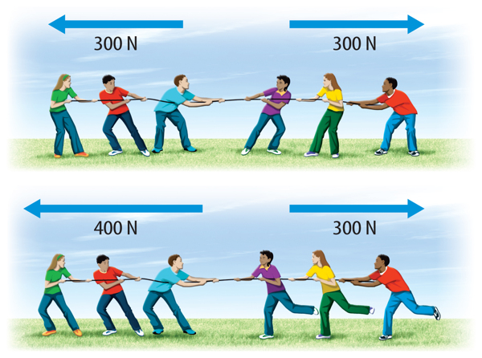



**Balanced Force Unbalanced Force**

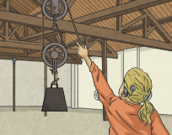****

A **lever** can be used to make a **small force lift** a lighter load. A lever always rests on a **pivot**.

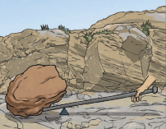

**Gears** or **cogs** can be used to **change** the **speed**, **force** or **direction** of a motion. When two gears are connected, they always turn in the opposite direction to each other.

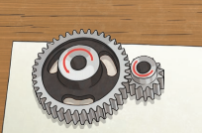

A **pulley** can be used to make a small **force** lift a lighter load. The more wheels in a pulley, the less force is needed to lift a **weight**.

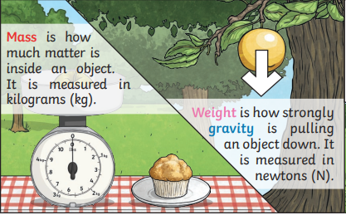

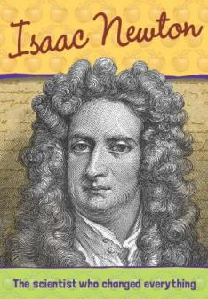

**Assessment**

* To identify forces acting on objects
* To recognise balanced and unbalanced forces
* To know what gravity is and how it is measured
* To research Sir Isaac Newton and his discoveries
* To explore the effect that gravity has on objects
* To identify the effect of friction that acts between moving surfaces
* To explain the effects of water resistance
* To plan and carry out an enquiry about air resistance
* To explore and design mechanisms

**Sir Isaac Newton is important because he is considered to be one of the most important scientists in history. He developed many things including: the laws of motion and the theory of gravity.**