KS1 Why is the Torah such a joy for the Jewish Community?
What should we know?
The Torah is an important book for Jews.
Jewish people believe:
- The Torah is a very important book, so important, that when they get to the end, they start to read it all over again.
- The Torah was given to the Jewish people from God.
- The Torah contains rules from God on how we should live.
- The Torah should be treated with respect.

Prior
learning
Jewish people believe good deeds like helping others are important.
Jewish people say prayers and blessings to God.
Shabbat is a day of rest.
At New Year God gives people a chance to put things right.

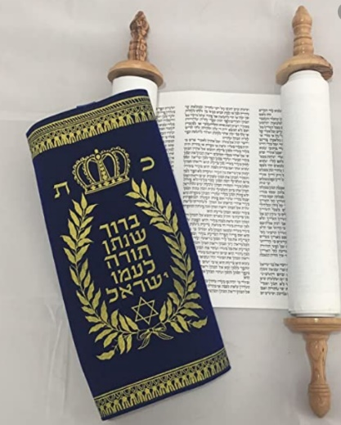
What should we be able to do?
Describe how the Torah is used in the synagogue.
Recall some of the stories of Moses e.g. 10 commandments or the birth of Moses.
Say that the Torah is kept in a synagogue or in a special ark.
Know the Torah contains rules.
Demonstrate how a mezuzah is used by Jewish people.

The Torah – an important book containing God’s rules.

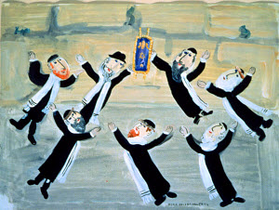

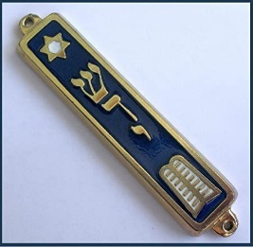

What words should we understand and be able to use?
Simchat Torah | A joyous holiday that celebrates the Jewish love of Torah. It marks the end of the annual cycle of weekly Torah readings and the beginning of the new cycle. | Mezuzah | A decorative case fixed to the entrance of a Jewish home containing some of the Torah which reminds people to love God and follow his commandments.
Torah | A very important book for all Jews containing God’s rules. | Moses | A great leader and teacher of Jewish history.
Bimah | Where the Torah scroll is placed ready for reading. | Holy Ark (Aron Kodesh) | The cupboard where the Torah scrolls are kept in a synagogue.
Synagogue | The Jewish place of prayer and study. | Hebrew | The language of the Torah.

