|  |  |
| --- | --- |
| Key Vocabulary | |
| Barge | A long flat-bottomed boat for carrying freight on canals and rivers. |
| Canal | A long man-made strip of water used for boat access to a bigger body of water. |
| City | A large human settlement. |
| County | A geographical region of a country. |
| Industry | Economic activity concerned with the processing of raw materials and manufacture of goods in factories. |
| Industrial Revolution | The transition to new manufacturing processes in the period from about 1760 to sometime between 1820 and 1840 |
| Freight | Goods transported in bulk by truck, train, ship or aircraft. |
| Trade | The activity of buying and selling, or exchanging goods between people or countries. |
| Urban | An urban area is the region surrounding a city where most jobs are non-agricultural. |
| Port | A docking place for ships on the coast of the ocean, a river or a lake. |



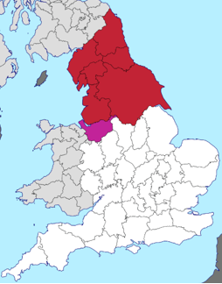

**Cities**

Newcastle Hull Durham Leeds York Sheffield Liverpool Manchester Chester Bradford Carlisle Sunderland Lancaster Preston

***Canals***

**Counties**

[Cheshire](https://en.wikipedia.org/wiki/Cheshire)   [Cumbria](https://en.wikipedia.org/wiki/Cumbria) County Durham [East Riding of Yorkshire](https://en.wikipedia.org/wiki/East_Riding_of_Yorkshire) Greater Manchester [Lancashire](https://en.wikipedia.org/wiki/Lancashire)  [Merseyside](https://en.wikipedia.org/wiki/Merseyside) [Northumberland](https://en.wikipedia.org/wiki/Northumberland) [North Yorkshire](https://en.wikipedia.org/wiki/North_Yorkshire) [South Yorkshire](https://en.wikipedia.org/wiki/South_Yorkshire) [Tyne and Wear](https://en.wikipedia.org/wiki/Tyne_and_Wear) West Yorkshire plus the areas of [North Lincolnshire](https://en.wikipedia.org/wiki/North_Lincolnshire) and [North East Lincolnshire](https://en.wikipedia.org/wiki/North_East_Lincolnshire)

*Canals were built as a way of transporting goods  
around the country.*  *Before canals were built, moving goods around was difficult  
as there were no engines. Items such as coal and food had to  
be moved by horse and cart.*

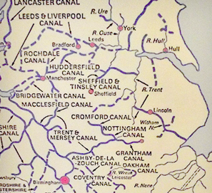The manmade canal system provided a smooth route for goodsaround the country. Canals could not be built to go everywhere.They were built to join up key areas of production (coal mines,mills, quarries) with large towns or ports.

**Geography**

Northern England is the area covered by [North East England](https://en.wikipedia.org/wiki/North_East_England), [North West England](https://en.wikipedia.org/wiki/North_West_England) and [Yorkshire and the Humber](https://en.wikipedia.org/wiki/Yorkshire_and_the_Humber). Dense **urban** areas run along the coasts and rivers. The needs of **trade** and **industry** produced an almost continuous thread of urbanisation including the **cities** of [Liverpool](https://en.wikipedia.org/wiki/Liverpool), [Manchester](https://en.wikipedia.org/wiki/Manchester), [Leeds](https://en.wikipedia.org/wiki/Leeds), and [Sheffield](https://en.wikipedia.org/wiki/Sheffield). These cities are all recent; most of them started as scattered villages before the **Industrial Revolution**. On the east coast, trade fuelled the growth of major **ports** such as [Kingston upon Hull](https://en.wikipedia.org/wiki/Kingston_upon_Hull) and [Newcastle upon Tyne](https://en.wikipedia.org/wiki/Newcastle_upon_Tyne). Approximately 90% of the population of the North live in one of its city regions: Liverpool, [Central Lancashire](https://en.wikipedia.org/wiki/Central_Lancashire), Manchester, Sheffield, Leeds, [Hull and Humber Ports](https://en.wikipedia.org/wiki/Humberside), [Tees Valley](https://en.wikipedia.org/wiki/Tees_Valley) and Tyne and Wear.

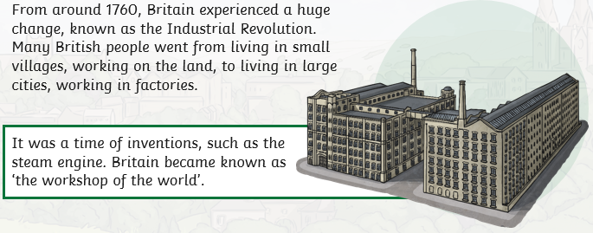****

**Industrial Revolution**

At the beginning of the [Industrial Revolution](https://en.wikipedia.org/wiki/Industrial_Revolution), Northern England had plentiful **coal** and [**water power**](https://en.wikipedia.org/wiki/Water_power). **Mining** and **milling**, which had been practiced on a small scale in the area for generations, began to grow. The boom in [industrial **textile manufacture**](https://en.wikipedia.org/wiki/Textile_manufacture_during_the_Industrial_Revolution) was helped by the damp climate and [soft water](https://en.wikipedia.org/wiki/Soft_water), making it easier to wash and work fibres.Readily available coal and the discovery of large iron deposits in Cumbria and [Cleveland](https://en.wikipedia.org/wiki/Cleveland_Hills) allowed **ironmaking** and [**steelmaking**](https://en.wikipedia.org/wiki/Steelmaking) to take root in the region. High quality steel in turn fed the [**shipyards**](https://en.wikipedia.org/wiki/Shipyard) that opened along the coasts, especially on Tyneside and at [Barrow-in-Furness](https://en.wikipedia.org/wiki/Barrow-in-Furness).

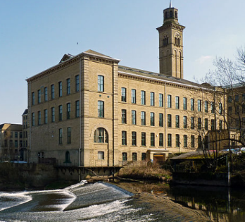

**Natural Resources**

[**Peat**](https://en.wikipedia.org/wiki/Peat) is found in thick, plentiful layers, and there are many large coalfields. [**Millstone grit**](https://en.wikipedia.org/wiki/Millstone_grit), a coarse-grained rock used to make [millstones](https://en.wikipedia.org/wiki/Millstone), is widespread, and the variety of other rock types is reflected in the architecture of the region, such as the bright red [**sandstone**](https://en.wikipedia.org/wiki/Sandstone) seen in buildings in [Chester](https://en.wikipedia.org/wiki/Chester), the cream-buff [Yorkstone](https://en.wikipedia.org/wiki/Yorkstone" \o "Yorkstone) and the distinctive purple [Doddington](https://en.wikipedia.org/wiki/Doddington,_Northumberland" \o "Doddington, Northumberland) sandstone. These sandstones also mean that most of Northern England has [very **soft water**](https://en.wikipedia.org/wiki/Water_hardness), which has influenced industry. Rich deposits of [**iron ore**](https://en.wikipedia.org/wiki/Iron_ore) are also plentiful. [Salt mining in Cheshire](https://en.wikipedia.org/wiki/Salt_in_Cheshire) has a long history, and both remaining [rock salt](https://en.wikipedia.org/wiki/Rock_salt) mines in Great Britain are in the North.

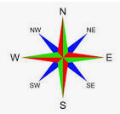

**Key texts:**



**Key Knowledge**

To name and locate counties and cities in the north of England To understand how land use and trade changed as a result of the Industrial Revolution To identify types of settlement and land use in the north of England To identify economic activity including trade links in the north of England To understand the impact of canals on economic activity and trade links To locate natural resources including energy, food, minerals and water in the north of England To use maps to describe features studied To use four and six-figure grid references, symbols and keys To use the eight points of the compass

 **Key Texts:**