
Science Knowledge Organiser Y5/6 – Earth and Space
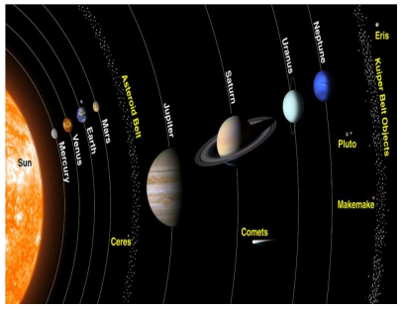
Key vocabulary
Celestial | Positioned in or relating to the sky, or outer space as observed in astronomy
Geocentric | Where people believed the earth was at the centre of the solar system
Galaxy | An extremely large group of stars and planets held together by gravity
Gravity | The force that attracts an object towards a larger object
Heliocentric | Representing the sun as the centre of the solar system, the modern view of the solar system
Moon | A natural satellite of any planet
Orbit | The curved path of a planet around the sun due to the attraction of gravity
Planet | A celestial body moving in orbit round a star
Solar system | The collection of eight planets and their moons in orbit round the sun
Star | A burning mass of gas that makes heat and light energy
Universe | All of space and everything in it (stars, planets and galaxies)

In space, planet Earth - the planet inhabited by humans - alongside other planets, stars, moons, asteroids and other objects form our Solar System.
Inside the Solar System, Earth and seven other planets orbit the Sun due to its gravitational pull. The sun is the biggest star in our Solar System. As Earth orbits the Sun, the Moon also orbits Earth.
It takes Earth 362.25 days to complete its orbit around the Sun, therefore every four years we have an extra day in February, we call this a leap year.
As the Earth orbits the Sun, it rotates. The half of the Earth facing the Sun will experience day whilst the part facing away will experience night. The sun does not move, but it is the Earth’s movement that makes the Sun appear to rise in the morning from the east and set in the evening in the west.

In medieval times it was believed that the Earth was flat; now we know it is approximately spherical. Aristotle believed that the Earth was at the centre of the solar system in what is called the geocentric model. Galileo believed that the Sun was at the centre of the universe in what is called the heliocentric model.

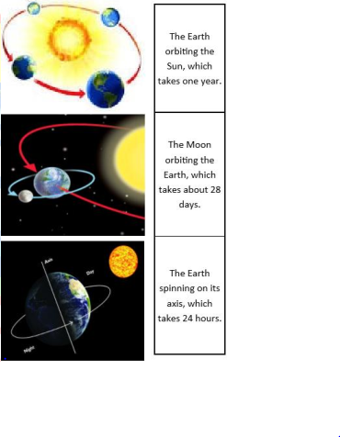
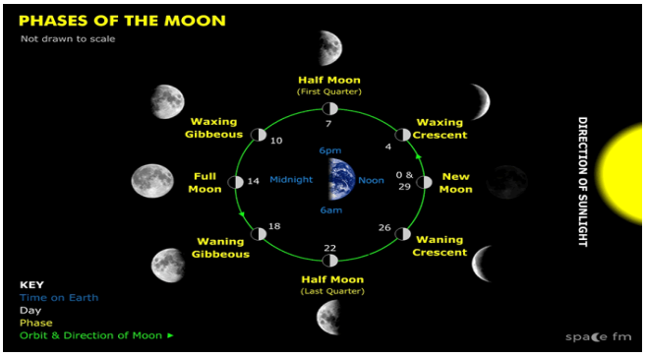
Assessment

- To investigate how the Sun and the planets make up our solar system
- To describe the movement of the Earth relative to the Sun in the solar system
- To describe the movement of other planets relative to the Sun in the solar system
- To describe the movement of the Moon relative to the Earth
- To observe and describe the phases of the Moon
- To understand that the Sun, Earth and Moon are approximately spherical bodies
- To use the idea of Earth’s rotation to explain day and night
- To use the idea of Earth’s rotation to explain the apparent movement of the Sun across the sky

During each lunar month, the Moon starts off unilluminated, this is called a New Moon. As more of the Moon becomes illuminated, it becomes a Full Moon and then back to unilluminated again. This process is continuous. Waxing occurs after a New Moon and before a Full Moon as more of the Moon illuminates. Waning occurs after a Full Moon and before a New Moon as less of the Moon is illuminated.
The Moon takes 28 days to orbit the Earth. We call this the lunar month. The Moon is not a light source and simply reflects the light from the Sun. The Moon also does not change shape, instead we see different amounts of the Moon’s surface depending on its position in relation to the Earth and Sun. These changes in the amount we can see are called the phases of the Moon.

